# Nova Scotia Multi Library Audit Report

**For:** Acadia University (Maggie Jean Neilson) and Novanet (Bill Slauenwhite)

**Date:** September 5, 2020

**From:** Lisa Snider, Access Changes Everything (ACE)  
**Contact Information:** (902) 717-5704 or [lisa@AccessChangesEverything.com](mailto:lisa@AccessChangesEverything.com)

Nova Scotia Multi Library Audit Report 1

Audit Information 3

Report Date 3

Reviewer 3

Web Site Information 3

Documents 4

Standard 4

Findings Information 4

Reviewer’s Testing Technologies 4

Third Party Testers 5

Third Party Testers Testing Technologies 5

Questions 6

Thank You 6

Summary of Audit Findings 6

Video and Audio 6

Magnification 11

Small Screens 14

Skip Links 15

Keyboard and Focus 17

Colour 23

Links 25

Navigation 27

Page Titles 31

iFrame 33

Font Type, Size and Styling 35

Headings 39

Images 40

Tables 44

Page Titles 45

ARIA Code 47

Search Mechanism 50

Search Results 56

Live Help Widget 65

CSS 76

HTML Code Errors 77

Disclaimer 78

Copyright 79

## Audit Information

### Report Date

July 2, 2020

Note: Testing was done from June 15-July 2, 2020

### Reviewer

Lisa Snider from Access Changes Everything (ACE).

### Web Site Information

The following is the report on the full accessibility audit of the following library related web pages that were chosen by the client for auditing:

* Acadia - Biology <https://libguides.acadiau.ca/biol> (Acadia Biology)
* Acadia - Business – Databases <https://libguides.acadiau.ca/business/databases> (Acadia Business)
* Acadia – Kinesiology – History of Sport and Recreation in Canada <https://libguides.acadiau.ca/KINE1243> (Acadia Kinesiology)
* NSCC –<https://subjectguides.nscc.ca/eResourceAccessibility> (NSCC)
* Mount Saint Vincent – Mathematics <https://libguides.msvu.ca/mathematics> (MSVU)
* Dalhousie – Aboriginal Law – Legislation <https://dal.ca.libguides.com/c.php?g=415481&p=2846360> (Dal Aboriginal Law)
* Live Help Novanet <https://www.novanet.ca/chat/> (Novanet Live Help)
* Live Help in a LibGuide – CBU – History <https://libguides.cbu.ca/c.php?g=704220&p=5008572> (CBU Live Help)
* Live Help Dalhousie University Libraries <https://libraries.dal.ca/> (Dal Live Help)

Extensive manual and automated testing of the web pages was completed by ACE, and user testers were employed in this audit to test specific parts of each web page. Only the public side of the websites were tested, unless login information was provided to test password only areas.

Note that the Live Help widgets were located in web pages. However, only the Live Help widget was tested, not the web page that was placed in as an iFrame.

### Documents

Document auditing was not part of this contract. The PowerPoint located on the Acadia Kinesiology site was quickly scanned, and it would not be accessible to some people with disabilities.

### Standard

The international standard that relates to website accessibility was considered, which is WCAG 2.1 (2.2 Draft) Level AA. This audit went far beyond WCAG 2.1 and 2.2 (Draft) Level AA, as the standards don’t include many accessibility best practices for people with different disabilities. General usability and accessibility best practices were considered, and included in this audit report.

### Findings Information

Lisa Snider provided a full audit of the web pages, and testers with different disabilities were employed to check specific areas on these web pages.

The web pages would not pass WCAG 2.1, or 2.2, Level AA, as there would be some criteria that would not be given a pass. As well, they may not have included usability and accessibility best practices.

The audit found areas that need improvement in terms of accessibility. The recommendations below have been noted as **\*\*PRIORITY\*\*** and **\*SECONDARY PRIORITY\*** to note their significance, in terms of remediation priorities.

The items marked **\*\*PRIORITY\*\*** should be remediated as soon as possible, as they are currently impacting some users with disabilities in a moderate to severe way. These users may not be able to access all, or any meaningful, information on the website, limiting access to it. The items marked **\*SECONDARY PRIORITY\*** also impact some users with disabilities, but this impact is judged as minimal to moderate for most users.

These categories are arbitrary, and were based on the consultant’s view of the standard, and their experience and knowledge. Please see the Disclaimer for more information.

### Reviewer’s Testing Technologies

* Mac OS Sierra 10.12.6 Firefox and Chrome
* PC Windows 10 Firefox and Chrome
* A minimum of 10 different accessibility related apps, plugins, extensions, as well as online checking software, were used in both Chrome and Firefox on PC and Mac.
* Manual testing was completed, and this included different assistive technologies.

### Third Party Testers

Paid testers were employed for this project. All testers were students at either Dalhousie University, MSVU or Acadia University. They were from both undergraduate, and graduate programs. They were also from different years, and first year undergraduate and graduate students were chosen deliberately were represented well overall.

Below, their information has been anonymized, to protect their identities.

* 2nd year MSVU student, who identified as having visual and hearing disabilities.
* 3rd year older MSVU student, who identified as having ADHD (cognitive disability).
* 3rd year older MSVU student, who identified as having a hearing disability, as well as mobility and perception disabilities.
* 1st year Dalhousie graduate student, who identified as having low vision.
* 1st year Dalhousie student, who identified as having ADD (cognitive disability).
* 1st year Dalhousie student, who identified as having autism, depression and social anxiety.
* 1st year Acadia student, who identified as having panic and anxiety (cognitive disabilities).
* 1st year Dalhousie graduate student, who identified as having a mobility disability and a pain related cognitive disability.

### Third Party Testers Testing Technologies

Note that some testers did not use any specific technologies. Macs and PCs were represented, one tester used an iPad Pro, and different browsers were used.

* Natural Reader Speech to Text (Google Chrome Extension)
* Phonak Compilot Bluetooth device (to assist hearing).
* VoiceOver screen reader on Google Chrome 83.0.4103.116 on Mac Catalina 10.15.5
* JAWS 2020 Home Use on Google Chrome 83.0.4103.116 on PC Windows 10
* Low vision accessibility features on iPad Pro, including Pinch to Zoom and large text.
* 200% and 400% magnification in Firefox 75.0 browser on Mac OS Sierra (v10.13).
* 200% and 400% magnification in Chrome 80.0.3987.163 (64-bit) on Mac OS Sierra (v10.13).
* Voice Control on iPhone 11 Pro iOS 13.3

### Questions

If you have questions about this report, please contact Lisa Snider at [lisa@AccessChangesEverything.com](mailto:lisa@AccessChangesEverything.com).

### **Thank You**

Thank you for allowing Access Changes Everything to provide accessibility consulting services for this project.

## Summary of Audit Findings

#### Video and Audio

##### Importance and Users Impacted

Video and audio need to be accessible to all users. Captions must be present on all videos for users who are Deaf/deaf or hard of hearing. However, these are also used by many other users, who don’t necessarily have a hearing disability. Other users can include learners with English as an additional language, people with low literacy, younger people with ADD and ADHD, etc.

Audio and video also need to have text transcripts that provide users with an exact text translation of the audio. Transcripts can be used by everyone, but are crucial for people who are Deaf-Blind.

As well, audio description needs to be present in audio and video to describe actions not spoken in words, or noted in the text transcript. This can be emotions, names, actions, clothing choices, positioning, etc. Audio description should be added to the text transcript, as well as to the soundtrack. This can be used by everyone, but is crucial for people who are blind, Deaf-Blind, low vision, Deaf/deaf and/or hard of hearing. Finally, sign language should be considered, as it can be the first language for many people who are Deaf/deaf.

##### Findings

**Acadia Biology **PRIORITY\*\***There are multiple videos on this web page. Almost all have captions that work well with the content. Two videos need to be remediated, and a third is only noted as optional.

One video is more problematic. It has very limited French captions, but needs to be resubmitted as a new YouTube video and ensure that captioning is done in English.

<https://www.youtube.com/watch?time_continue=18&v=i_CXrhGeVFA&feature=emb_logo>

A second video is less problematic, but needs to have more captioning and in video text added, from 29 seconds to the end. The video, from 29 seconds onwards, is showing an example of how to scroll through the left side navigation. This needs to be captioned and have in video text added.

<https://www.youtube.com/watch?time_continue=52&v=6pi_vA4cehQ&feature=emb_logo>

Finally, there is optional remediation to note for two videos. Even though two videos only have music and in video text, they should be captioned if possible. In this case, YouTube can’t auto caption this video, so captions need to be manually added. This is recommended, because some people prefer captions to the in video text.

<https://www.youtube.com/watch?time_continue=3&v=eJa_22w09QE&feature=emb_logo>

<https://www.youtube.com/watch?time_continue=27&v=vTeE3m1QE5o&feature=emb_logo>

For all videos, a text transcript **MUST** be made available for each of them for users who are Deaf-Blind.

The testers were asked to test the videos on this page. The tester who was older with ADHD, noted a couple of items and improvement suggestions. First, they noted that pausing or stopping the video wasn’t as easy as starting it:

“I have been watching a lot of videos for an online course, so it was easy to navigate all the controls for the video. The one thing I struggle with and I found this to happen here is that I could not stop or pause the video. . The initial play button is in the centre of the video and then you have to navigate to the lower left side to pause. This always trips me up. It tripped me up more so as there were so many videos on the page, I ended up starting a few by accident in the process of trying to stop the first one.”

This tester also mentioned that the page felt a bit cluttered, due to the many videos. Their suggestions are recommended by the consultant:

Maybe a little space between videos to separate them. They all blur into each other with the blue cloud background. The last one sticks out with a black border around it. But they are still all too close to each other. And they are very busy – they have share, watch later and subscribe on the top of every one, which is actually really cool to have the quick access to these options, but it makes the video visually too cluttered as they all run into one another. The big black titles actually work really well (one doesn’t have it and i don’t actually know what the video is), why do they have two titles. I would take away the white title at the top left.

The tester with hearing, mobility and perception disabilities noted issues with the videos on this page. Their notes below are recommended by the consultant as well.

“The video experience is good as the video is shown through “text boxes” and there was no audio (with the exception of music). However, if I was reading the closed captions which is the exact same wording as on screen, the video is too fast for the captions to keep up preventing the ability to read the captions. Since the “text boxes” were already stating the information, it may not be a difficulty as there is no verbal audio to follow and the information is still accessible without the captions. However, those who read the captions out of habit or do not realize that there is no voice will find it quite difficult to follow. “

“The text was quite small even with a good vision which makes it difficult to notice the words. Another aspect is the lack of headings for the videos, not all videos have a clear thumbnail that addresses the topic of the video and without the headings, it is hard to know which video is giving what information. The navigation area is easy to use and clear which helps with finding information without prior knowledge simple. “

The tester with mobility and cognitive disabilities, who uses text to speech software, mentioned an important issue in relation to these videos (and this relates to all others):

“How to-get help citing sources video. Played around with the controls. Turned on close caption, but given that the audio was simply music there was no need. Additionally, the step-by-step instructions were already written out in the video. This would be an issue for those who have trouble reading/difficulty reading (the instructions went by quickly and I know individuals with dyslexia need time to decode)/vision impairment, as you cannot use speech to text software on a video. This would be one thing I would change.”

The tester with low vision, who uses magnification, highlighted three items of note that relate to the videos. The consultant would advise to consider all three suggestions, as they would improve the videos for all users.

“I watched the video “How to access our online databases” - Could not open the video full screen as the browser (Google Chrome) does not support this. - The colours were a bit jarring. For example, the purple speech bubble seemed similar in font/ theme to the page. The text blended in somewhat, however it was readable once the screen has been zoomed in.”

“The mouse cursor on the video was extremely small. I had to pause the video a few times and enlarge the screen using the iPad’s pinch zoom to realise what was happening on the video. A possible solution would be to highlight where the mouse is or circle the button when demonstrating which buttons the user is expected to press”.

“Having the music audio rather than verbal directions was challenging It might be worth highlighting important things in high contrast colours and then describing what it is on an audio track accompanying the video rather than just having the music.”

The tester with a visual and hearing disability, who used a screen reader, had one important comment, and this is recommended by the consultant:

“…It was easy to get to the video as well. I just had to Tab through. I used the controls and they worked. However, Jaws did not read the instructions displayed in the video as my Mac did. This means I did not get the instructions in the video. It just played it and without sight, I wouldn’t know what the video was about. I would advice that they do a voice over on the video to make it accessible for all.”

One last comment came from this tester, who used a screen reader. This is something that is optional, but should be considered:

“…Watching a video was very easy. I only had to Tab through each item. The controls worked fine on the video. I was most impressed that the video was screen reader accessible – I mean that voice over read the instructions displayed in the video while the video was playing. The only thing I think needs improvement is that after watching the video, I had to leave my browser and go back to the page to view the main page again. If they could make it easier to get back to the main page after watching the video, that would be good.”

**Acadia Business**

No issues noted.

**Acadia Kinesiology**

No issues noted.

**NSCC**

No issues noted.

**MSVU**

No issues noted.

**Dal Aboriginal Law **PRIORITY\*\***

There are three videos on this web page, and all **REQUIRE** captioning and text transcripts. See the Acadia Biology section for more information.

The tester who had hearing, mobility and perception disabilities had a few notes about these videos that echo what the consultant said above:

“The video has no captions and the guided visuals do not enough context on why it is pointed or highlighted as the voice is giving the information. While I can hear the sound of the voice, the words itself I cannot gain as I have no idea what is the purpose of presenting the video to attempt to string words together logically leading to just looking at the video cluelessly. The videos are not accessible to D/deaf and hard of hearing as the majority of the required information to understand the context of the video is through audio…”  
  
“Headings above a video is advisable as the thumbnails are quite busy to notice the titles in the video. There is also the issue of once you click a video, the heading disappears because it is in the thumbnail so if a person were to use or follow the video if struggling to find the videos without adequate headings would be difficult.”

The tester with mobility and cognitive disabilities, who uses text to speech software, made very good suggestions that the consultant recommends:

“Prefacing the videos in text allow users who use text to speech software to read the page, and understand if they want to watch the video. Right now, I don’t know what the videos are about. Add in a label before each video that works with text to speech software.”

The tester with the hearing and visual disability, who used a screen reader noted major issues with the video on the Dal LibGuide page. It is recommended that Vimeo not be used, as the player is not as accessible as YouTube for viewers without sight.

“Voice over- first, it didn’t tell me the video I was about to play. It just said “Play”. In the video, it still doesn’t say the name even after tab to and out of the video. I only got that it was about statutes from the man doing the voice over. The video had voice over which is good. I tried to pause the video but its not pausing, it keeps playing. With Jaws- I also didn’t know what video I was playing until the person said it. Good thing the video had voice over. I also couldn’t pause it. My attempts to pause it made it full screen. The volume control was clear.”

The tester related that:

“They need to make the video controls better and state the title of the video before it is played. It also needs to be able to pause.”

#### Magnification

##### Importance and Users Impacted

Web pages need to be tested with 200% and 400% browser magnification applied (at 1280 x 800 resolution as well as 1440 x 900), to ensure all users can access the web pages. The magnification is tested to ensure that everyone who uses magnification (only up to 400%), such as people with low vision and/or other disabilities, can access the site with it enabled.

##### Findings

**Acadia Biology **PRIORITY\*\***There were issues noted at 200% (1440 x 900 resolution). The issue involved the right side ‘top of page’ link. When it moved down the page, it obscured other links, and this needs to be remediated. Note that this happens on mobile without magnification as well. One example is noted below.

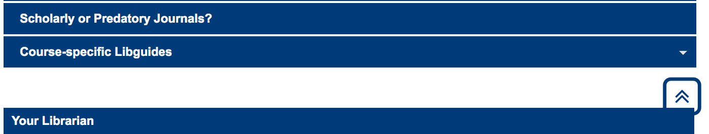

Another issue found when magnification was at 200% was that the sub menu navigation obscured the navigation below it. The script needs to be changed so that the navigation below is not obscured, and works more like a true accessible accordion. Note that this happens on mobile without magnification as well. One example is noted below.

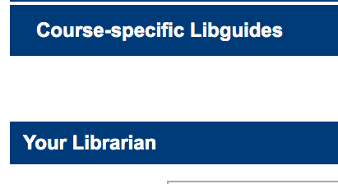

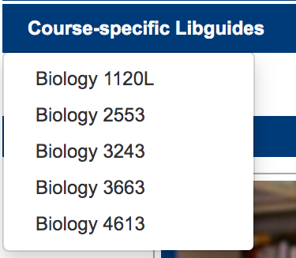

**Acadia Business **PRIORITY\*\***

There were issues noted at 200% and 400% (1440 x 900 resolution). The issue involved the right side ‘top of page’ link. When it moved down the page, it obscured other links, and this needs to be remediated. Note that this happens on mobile without magnification as well. One example is noted below.

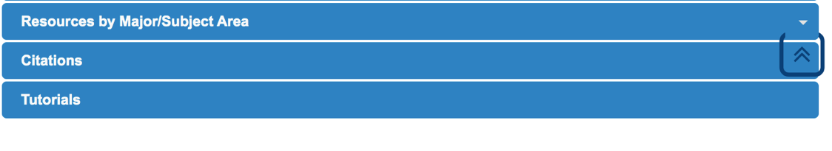

**Acadia Kinesiology **PRIORITY\*\***

There were issues noted at 200% and 400% (1440 x 900 resolution). The issue involved the right side ‘top of page’ link. When it moved down the page, it obscured other links, and this needs to be remediated. Note that this happens on mobile without magnification as well. One example is noted below.

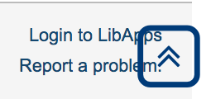

**NSCC **PRIORITY\*\***

There were issues noted at 200% (1440 x 900 resolution). The issue involved the right side ‘top of page’ link. When it moved down the page, it obscured other links, and this needs to be remediated. Note that this happens on mobile without magnification as well. One example is noted below.

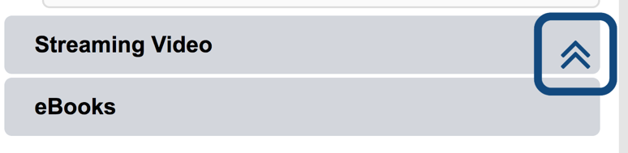

**MSVU **PRIORITY\*\***

There were issues noted at 200% and 400% (1440 x 900 resolution). The issue involved the right side ‘top of page’ link. When it moved down the page, it obscured other links, and this needs to be remediated. Note that this happens on mobile without magnification as well. Two examples are noted below.

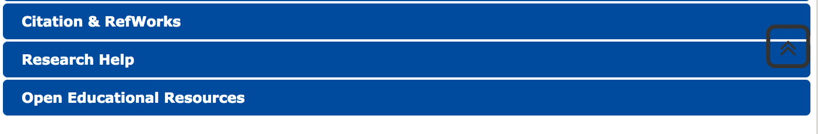

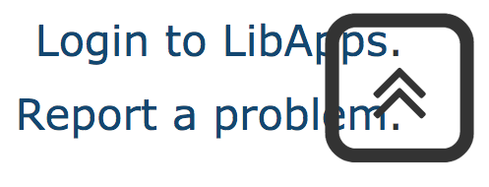

**Dal Aboriginal Law **PRIORITY\*\***

There were issues noted at 200% and 400% (1440 x 900 resolution). The issue involved the right side ‘top of page’ link. When it moved down the page, it obscured other links, and this needs to be remediated. Note that this happens on mobile without magnification as well. One example is noted below.

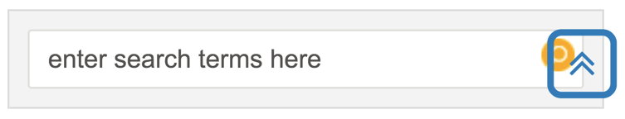

#### Small Screens

##### Importance and Users Impacted

Websites should be viewable and usable to users who view it on mobile phones (be responsive). WCAG 2.1 requires us to check the web sites on a small screen size of 320 pixels wide, so that no side scrolling is noted, and all elements and content are usable and accessible. As well, web pages should be accessible to everyone, whether users employ portrait or landscape mode, or they switch between the two modes. This is important for people who have low vision, and/or physical disabilities, and/or cognitive disabilities.

##### Findings

**Acadia Biology**No issues noted.

**Acadia Business**

No issues noted.

**Acadia Kinesiology**

No issues noted.

**NSCC**

No issues noted.

**MSVU **PRIORITY\*\***

There were issues noted with the formatting of the LiveHelp, where the code of conduct link obscures the text area, when on a screen of 320 x 568 in Portrait mode. This should be remediated.

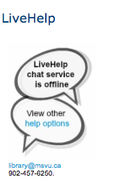 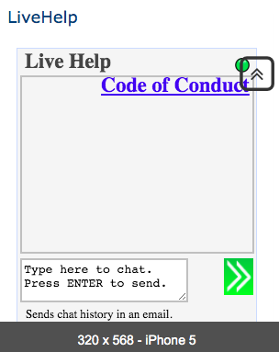

As well, on the iPhone 11 Pro Portrait and Landscape modes, there were two issues noted. One was the Code of Conduct issue, as shown below in Landscape mode.

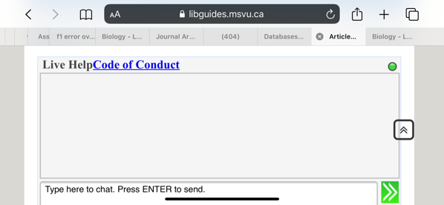

The other issue was found in the upside down picture of the librarian in both Portrait and Landscape modes.

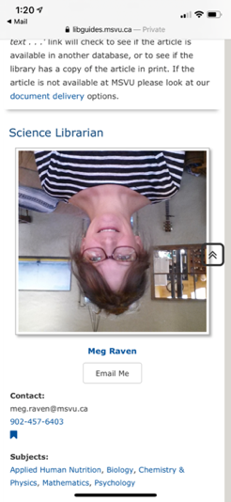

**Dal Aboriginal Law**

No issues noted.

#### Skip Links

##### Importance and Users Impacted

Best practice for web pages is for at least one ‘skip to’ link to be present at the top of each web page. This is used primarily, but not exclusively, by screen reader users who are blind, Deaf-Blind or have low vision, as well as people with sight, who use keyboard navigation. It gives these users a quick way to navigate the page from the top to the main content area, skipping repeated navigation, banner, etc. areas.

##### Findings

**Acadia Biology *SECONDARY PRIORITY\***There is an invisible skip link present, when activated, however it goes to How to Access Online Resources. While this is technically correct, the user misses out on the Librarian contact information (Your Librarian) and Follow the Library sections. This should be remediated, so the Skip anchor is placed next to Your Librarian.

** **

**Acadia Business**

No issues noted.

**Acadia Kinesiology**

No issues noted.

**NSCC**

No issues noted.

**MSVU **PRIORITY\*\***

There is no skip link (skip to content) present, and one needs to be added.

**Dal Aboriginal Law *SECONDARY PRIORITY\***

There is an invisible skip link present, when activated, however it goes to Legislation. While this is technically correct, the user misses out on the Links & Tasks and Search sections. This should be remediated, so the Skip anchor is placed next to Links & Tasks.

 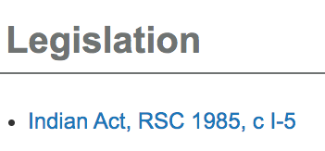

#### Keyboard and Focus

##### Importance and Users Impacted

Some users may use a keyboard, but not a mouse, on a traditional computer, device and/or smartphone for navigation. These users may use the tab key, enter key, spacebar and arrow keys to navigate the page content. These keyboard users should be able to tab through links, buttons, form elements, menu items, etc. from top to bottom, following the visual order that sighted users would access.

Many people can use keyboard only navigation, including screen reader users who are blind, Deaf-Blind or low vision, and/or people with physical disabilities, and/or people who use voice recognition software. These users may rely on tabbing (or similar with voice recognition) on each link and form element for navigation through a web page.

As well, we need to ensure that all links, form elements, buttons, etc. have very good visible focus, where a coloured line or box is highlighting the tab focus (colour depends on the background colour-see the Colour Contrast and Combinations Section) through the :focus selector in the css file. This is crucial for sighted users who use keyboard only navigation, as they count on it to see where they are in the page.

Currently, some browsers show this focus automatically without code being present. However, this code should be in the css file for every link, button, form element, etc. This will ensure that different browsers show the focus in a similar way, and all users can easily and quickly access content.

The new WCAG 2.2 requirement in 2.4.11 has been thought to mean (it just came out March 2020) that there needs to be a minimum focus line thickness of 2 CSS pixels, and the colour needs to be checked towards the colour ratio, mentioned in the Colour Section.

##### Findings

**Acadia Biology **PRIORITY\*\***The order of the focus on links and input boxes as one tabs down a page does not need remediation. However, the focus indicator for links and input boxes needs to be remediated.

Some links and input areas have a focus indicator, such as the Search box, some text links, etc. Others have no focus indicator at all, and even the ones that do have it need it to be more visible with a thick colour line around the link or input area, at a minimum,

Examples of links that have focus that need to be made thicker are shown below,





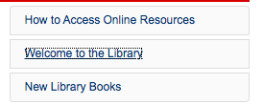



Examples of links without focus at all, and need thick focus links are shown below.

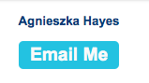

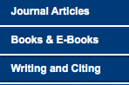

**Acadia Business **PRIORITY\*\***

The order of the focus on links and input boxes as one tabs down a page does not need remediation. However, the focus indicator for links and input boxes needs to be remediated.

Some links and input areas have a focus indicator, such as the Search box, some text links, etc. Others have no focus indicator at all, and even the ones that do have it need it to be more visible with a thick colour line around the link or input area, at a minimum,

Examples of links that have focus that need to be made thicker are shown below,





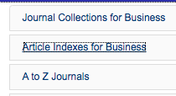



Examples of links without focus at all, and need thick focus links are shown below.



**Acadia Kinesiology **PRIORITY\*\***

The order of the focus on links and input boxes as one tabs down a page does not need remediation. However, the focus indicator for links and input boxes needs to be remediated.

Some links and input areas have a focus indicator, such as the Search box, some text links, etc. Others have no focus indicator at all, and even the ones that do have it need it to be more visible with a thick colour line around the link or input area, at a minimum,

Examples of links that have focus that need to be made thicker are shown below,



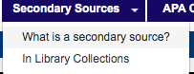

Examples of links without focus at all, and need thick focus links are shown below.



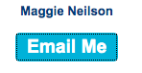

**NSCC **PRIORITY\*\***

The order of the focus on links and input boxes as one tabs down a page does not need remediation. However, the focus indicator for links and input boxes needs to be remediated.

Some links and input areas have a focus indicator, such as the Search box, some text links, etc. Others have no focus indicator at all, and even the ones that do have it need it to be more visible with a thick colour line around the link or input area, at a minimum,

Examples of links that have focus that need to be made thicker are shown below.





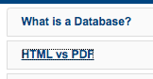

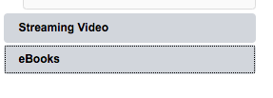

**MSVU **PRIORITY\*\***

The order of the focus on links and input boxes as one tabs down a page does not need remediation. However, the focus indicator for links and input boxes needs to be remediated.

Some links and input areas have a focus indicator, such as the Search box, some text links, etc. Others have no focus indicator at all, and even the ones that do have it need it to be more visible with a thick colour line around the link or input area, at a minimum,

Examples of links that have focus that need to be made thicker are shown below.

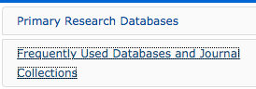



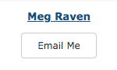

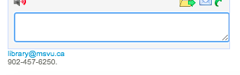

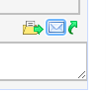

Examples of links without focus at all, and need thick focus links are shown below.

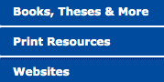

**Dal Aboriginal Law **PRIORITY\*\***

The order of the focus on links and input boxes as one tabs down a page does not need remediation. However, the focus indicator for links and input boxes needs to be remediated.

Some links and input areas have a focus indicator, such as the Search box, some text links, etc. Others have no focus indicator at all, and even the ones that do have it need it to be more visible with a thick colour line around the link or input area, at a minimum,

Examples of links that have focus that need to be made thicker are shown below,





Examples of links without focus at all, and need thick focus links are shown below.

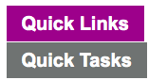

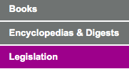

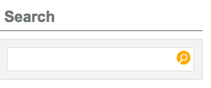

#### Colour

##### Importance and Users Impacted

The colour combinations used in text and background, both on images and text, need to pass the WCAG 2.1 Level AA colour contrast ratios (in this case the ratio of 4.5:1 for regular text). This will help make the text easier to read for the majority of users, including elders and people with visual disabilities, such as low vision, and/or cognitive, neurological, intellectual and/or learning disabilities.

There are many checkers to help with this, including the online WebAIM Color Contrast Checker (<https://webaim.org/resources/contrastchecker/>), and the downloadable Colour Contrast Analyser (<https://developer.paciellogroup.com/resources/contrastanalyser/>). Note that all colour combinations should be rechecked, including all states of links, buttons, images, etc.

As well, colour combinations need to be checked for colour blindness issues. Some colour combinations for text and background, such as red/green, blue/yellow, etc. can be problematic for these users.

##### Findings

**Acadia Biology **PRIORITY\*\***There was one colour contrast issue on the site, noted in the screen print below, and it must be remediated.

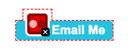

**Acadia Business **PRIORITY\*\***

There were many colour contrast issues on the site, noted in the example screen prints below, and they must be remediated. All headings and side navigation areas need to be remediated for colour contrast.

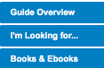



There was one link issue present. There was a generic ‘click here’ link noted on the page. This link needs to be made more descriptive, so all viewers know where they are going when it is activated.



**Acadia Kinesiology **PRIORITY\*\***There was one colour contrast issue on the site, noted in the screen print below, and it must be remediated.



**NSCC**

No issues noted.

**MSVU**

No issues noted.

**Dal Aboriginal Law **PRIORITY\*\***

There were three colour contrast issues on the site, noted in the screen prints below, and they must be remediated.

 

Link colours are hard to differentiate from the text, they should be reconsidered, I possible, This is especially true for links on the grey backgrounds, such as at the bottom of the page.One potential fix is to underline links in text areas, to make they stand out more.

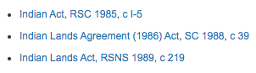



#### Links

##### Importance and Users Impacted

Text links need to be descriptive to tell all users, including those with limited or no sight and those with cognitive disabilities, what they are, and where the user will go when activated. Text links should also follow best practice of being underlined, being in a different colour than the text (with strong contrast) and each being unique, not generic such as ‘Click here’. Images, with or without text, can also be linked. Those will be covered in the Images Section.

In the rare cases where links can’t be given descriptive text (and this should be done with extreme caution), then at a minimum an aria-label can be applied to the code to provide that description (example, aria-label="Description of link."). This code can be problematic for screen readers, and/or voice recognition software.

##### Findings

**Acadia Biology *SECONDARY PRIORITY\***

There was one issue noted here that applies to all the sites below. The print icon and text towards the bottom of the page are very small. This was put in as a convenience, however it should still be usable for all. The tester with hearing, mobility and perception disabilities noted this as well:

“My original direction of printing the page is to do it by the browser to print. However, it does not work with that method. I did happen to find the print page link which was small and not very noticeable. This method allows the preview to appear to print but again, not noticeable and small so a person would have to be looking for it.”

Note that the tester with mobility and cognitive disabilities, who uses text to speech software, related that the print option froze their browser and they couldn’t ‘unfreeze’ it. It is not known why this issue occurred, and the mechanism should be checked.

The issue with the top of page link noted in the Dal Aboriginal Law section should be noted.

**Acadia Business *SECONDARY PRIORITY\***

There was one link issue present. There was a generic ‘click here’ link noted on the page. This link needs to be made more descriptive, so all viewers know where they are going when it is activated.



The issue with the top of page link noted in the Dal Aboriginal Law section should be noted. Note the small print icon and text in Acadia Biology.

**Acadia Kinesiology *SECONDARY PRIORITY\***The issue with the top of page link noted in the Dal Aboriginal Law section should be noted. Note the small print icon and text in Acadia Biology.

**NSCC *SECONDARY PRIORITY\***

The issue with the top of page link noted in the Dal Aboriginal Law section should be noted. Note the small print icon and text in Acadia Biology.

**MSVU **PRIORITY\*\***

The tester with low vision, who uses magnification, found it hard to find a specific link (ERIC) on the MSVU Mathematics page. It is highly recommended that the links be bolded to make them stand out from the black text.

“I found the search for ERIC (EBSCO) somewhat cumbersome. The headings for each journal collection is in a light blue, and is only slightly bigger than the text itself. This led me to generally skim through the segments and so I had to go back and look closer using the IPad’s pinch zoom feature. It would be helpful to enlarge these titles.”

The issue with the top of page link noted in the Dal Aboriginal Law section should be noted. Note the small print icon and text in Acadia Biology.

**Dal Aboriginal Law **PRIORITY\*\***

Link colours are hard to differentiate from the text, they should be reconsidered, I possible, This is especially true for links on the grey backgrounds, such as at the bottom of the page. One potential fix is to underline links in text areas, to make they stand out more.





The tester who had hearing, mobility and perception disabilities had one note about the top of page icon link, and this applies to the other sites that use similar ones.

“The top of the page link was originally difficult as you reach the bottom and expect to see it with the other links. It took a minute to realize that the arrow on the right side of the screen was not previously there concluding the fact that it is the top of the page link. If not noticing the entire screen, it would just be easier to scroll back up or reload to get back to the top of the page.”

Note the small print icon and text in Acadia Biology.

#### Navigation

##### Importance and Users Impacted

The website should be as easy as possible to navigate for all users. The navigation should be consistent throughout the site, not only in placement, but also in the text used to describe each link. The navigation should also ideally show viewers where they are in the site hierarchy in some way. The way the navigation structures are coded is also important, as it needs to ensure that users can access the navigation, whether they are using different technology or not.

##### Findings

**Acadia Biology**No issues noted by the consultant. The testers were asked to test the navigation area on the left top of the page.

The tester who is older, and has ADHD, noted this about that navigation area. This should be considered to see if any improvements can be made:

“I missed [the New Library Books section]. I skimmed right over “home” and its unbannered subtitles, including “new library books” and read straight through all the blue bannered titles in the library navigation columns. I had to look again. Caught it the third time.”

**Acadia Business**

No issues noted.

**Acadia Kinesiology *SECONDARY PRIORITY\***

A different navigation design, positioning and layout was used on this site, compared to the Acadia Biology and Business sites. It is recommended that for ease of use that all LibGuides use the same navigation design, position and layout, if possible. In this case, the two other pages using the left side navigation may be easier to use for all users, so it recommended that be used for all LibGuides.

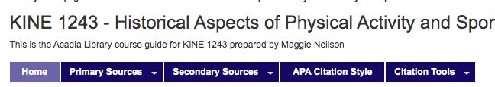

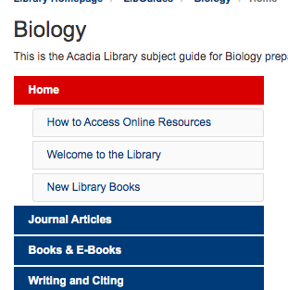

**NSCC**

No issues noted.

**MSVU**

There was one issue noted that related to navigation. In the Linking Instruction area widgets areas, the drop down revealed text and an image. The image should be checked to ensure the alternative text is descriptive. As well, the text indicates that the user should go ‘to the right side of the page’. This needs to be reworded as many users won’t see a ‘right side’, including users without sight.

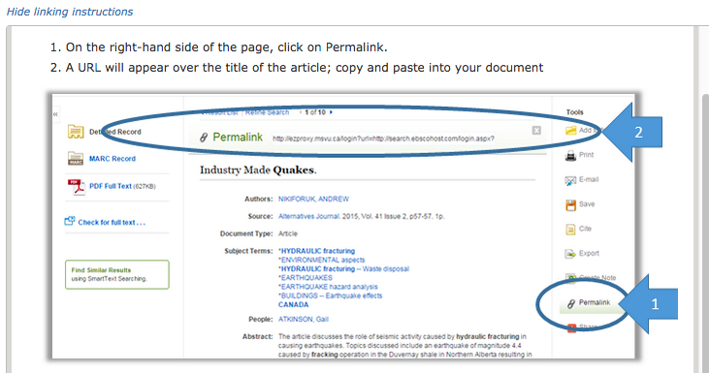

**Dal Aboriginal Law**

There was one issue noted in the code used for the left side navigation area. The list code is problematic in this area, as there is no <ul> or <ol> present in the code. This must be remediated, so the code is valid/

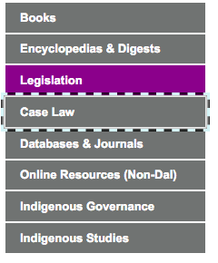

The tester with mobility and cognitive disabilities, who uses text to speech software also noted major issues that must be remediated with the navigation and Quick Links area:

“[The main navigation area was]…not usable with text to speech software. It only reads “aboriginal law” and then skips all the way down to “Legislation”—essentially skips out on “Dalhousie University Libraries/Libguides…” which shows you where you are on the side. Skips the navigational/tab options “books; encyclopedia…”, links and tasks and everything under there; and the “search bar”. This definitely needs to be changed as your skipping valuable info. “

Issues were also noted by this tester in the Quick Links area:

“Software wont read Quick links so I wouldn’t even be able to find this section if I only rely on my software. I tried to highlight “quick links” and then get software to read it to no avail. I was able to highlight the list under there, but again, if you cant read “quick links” the items under there are useless to you. Please fix this. I clicked on “Law databases” and the link worked for me… again, sotware cant read out loud “quick tasks.”

The tester with low vision, who uses magnification, provided a suggestion to be considered in terms of the links in the Quick Link area.

“Under the quick links tab, there is a list of hyperlinks. One section is “Heinonline” which took me to a Dalhousie sign in page. The experience in accessing the link was ok, however I struggled with the explanation. Currently, when you tap the database it takes you to that link in a new tab.

When i returned to the original tab i found a description of the database in a text box under the name of the database. It appears that this site has been optimised for desktop PCs (the description appears when you hover your mouse over the link) and so on a mobile browser this feature is not very compatible. I had to enlarge the text to view it which was a challenging experience.

Perhaps the descriptions should be short and easily readable. For example, the description for HeinOnline is “HeinOnline, named to the 2007 EContent 100 "list of companies that matter most in the digital industry," is the world's largest image-based legal research database. HeinOnline is an especially useful collection of full-text legal periodicals but also contains a vast array of addiitional legal content.

All content within HeinOnline is image-based in PDF format, from inception and fully searchable. Our subscriptions includes the following databases: Law Journal Library, English...” This is far too long and could be made shorter to improve the readability.”

This tester also noted that the tabs were not optimal for non-traditional computers. The consultant would agree, as this link area works better on traditional computers with larger screens.

“I didn’t like the quick links/quick tasks tabs as it felt like they weren’t optimised for mobile students who struggle to read their long descriptions.”

The tester with the hearing and visual disability, who used a screen reader noted confusion with the Quick Links area, but they were able to use the links in the tabs without issue.

“Using voice over, I heard “Quick links. Tab 2 list items”, then I tabbed, and it said quick tasks. im assuming quick tasks is not in the list but if it is, then I guess that’s what I found. Using Jaws, it was the exact same thing as using Voice over.”

#### Page Titles

##### Importance and Users Impacted

Descriptive and unique page titles, which have correct spacing and grammar, should be present in every html file at the top, in the <title> tag. These are used as the title in the browser tab, and as the title when a user bookmarks the web page. These page titles are also usually the first thing screen reader users hear when they come to a page. The screen reader software usually reads the page title first, before any other content, so it is a very important component.

##### Findings

**Acadia Biology **PRIORITY\*\***Page titles exist, and no issues were noted. However, see the issue of the main titles noted for Acadia Business and Dal Aboriginal Law, because the same issues apply here. They should be remediated, and then the page titles (<title>) may have to be adjusted accordingly.

**Acadia Business **PRIORITY\*\***

Page titles exist, and no issues were noted. However, main titles on all web pages need to be reconsidered, and once they are remediated the page titles (<title>) may need to be adjusted accordingly.

One example is the Journal Articles/Databases subpage in the Business LibGuide section. This page, along with every other page in the Business section, has the same main title of ‘Business’.

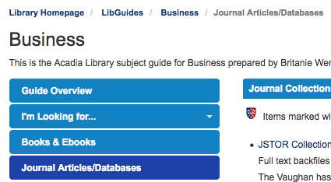

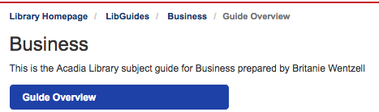

All users need more descriptive main titles (<h1>), and these on all web pages must be remediated. In this example, the main title in both pages is ‘Business’. This should be changed so it reflects the page the user is on, and then the page title should echo it.

CURRENT

Business

RECOMMENDED

Business- Journal Articles/Databases

**Acadia Kinesiology **PRIORITY\*\***Page titles exist, and no issues were noted. However, see the issue of the main titles noted for Acadia Business and Dal Aboriginal Law, because the same issues apply here. They should be remediated, and then the page titles (<title>) may have to be adjusted accordingly.

**NSCC **PRIORITY\*\***Page titles exist, and no issues were noted. However, see the issue of the main titles noted for Acadia Business and Dal Aboriginal Law, because the same issues apply here. They should be remediated, and then the page titles (<title>) may have to be adjusted accordingly.

**MSVU **PRIORITY\*\***Page titles exist, and no issues were noted. However, see the issue of the main titles noted for Acadia Business and Dal Aboriginal Law, because the same issues apply here. They should be remediated, and then the page titles (<title>) may have to be adjusted accordingly.

**Dal Aboriginal Law **PRIORITY\*\***

Page titles exist, and no issues were noted. However, main titles on all web pages need to be reconsidered, and once they are remediated the page titles (<title>) may need to be adjusted accordingly.

One example is the Legislation subpage in the Aboriginal Law LibGuide section. This page, along with every other page in this section, has the same main title of ‘Aboriginal Law’.

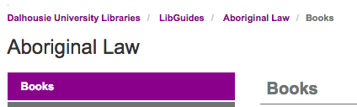

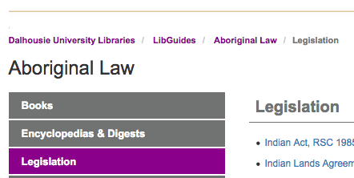

All users need more descriptive main titles (<h1>), and these on all web pages must be remediated. In this example, the main title in both pages is ‘Aboriginal Law’. This should be changed so it reflects the page the user is on, and then the page title should echo it.

CURRENT

Aboriginal Law

RECOMMENDED

Aboriginal Law-Legislation

#### iFrame

##### Importance and Users Impacted

iFrames are a way to link to a web page, video, etc. inside a frame in another web page. These are required to have a title, to provide information about the content of the linked item, primarily for people who use screen readers.

##### Findings

**Acadia Biology **PRIORITY\*\***

Seven iFrames were noted and all are needing a title added to them. These must be remediated. For example, the How to Get Help Online video needs to have a title added to it, so all users know what is inside the iFrame.

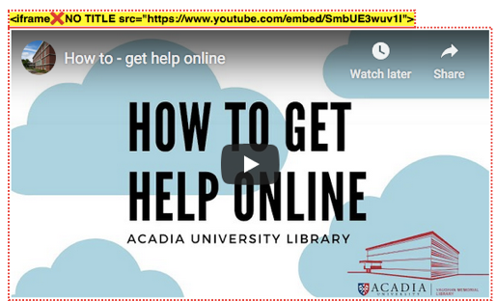

CURRENT

<div id="s-lg-content-35146053" class="s-lg-widget "><iframe width="560" height="315" src="https://www.youtube.com/embed/SmbUE3wuv1I" frameborder="0" allow="accelerometer; autoplay; encrypted-media; gyroscope; picture-in-picture" allowfullscreen></iframe>

RECOMMENDED

<div id="s-lg-content-35146053" class="s-lg-widget "><iframe width="560" height="315" src="https://www.youtube.com/embed/SmbUE3wuv1I" frameborder="0" allow="accelerometer; autoplay; encrypted-media; gyroscope; picture-in-picture" allowfullscreen **title=”YouTube video How to Get Help Online Acadia University Library**></iframe>

**Acadia Business **PRIORITY\*\***

One iFrame was noted and it needs a title added to the code. This must be remediated. See the example in Acadia Biology for how to fix this error.

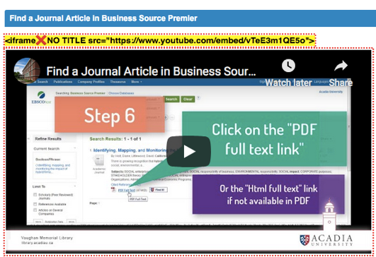

**Acadia Kinesiology**

No issues noted.

**NSCC**

No issues noted.

**MSVU **PRIORITY\*\***

Five iFrames are present and all need to be examined to ensure a title has been included in them. For example, two iFrames were noted and they need a title added to the code. See the example in Acadia Biology for how to fix this error.

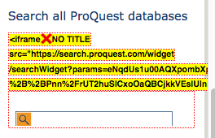

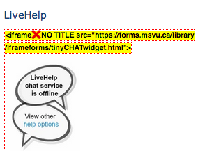

**Dal Aboriginal Law **PRIORITY\*\***

Three iFrames were noted and they need a title added to the code. These must be remediated. See the example in Acadia Biology for how to fix this error.

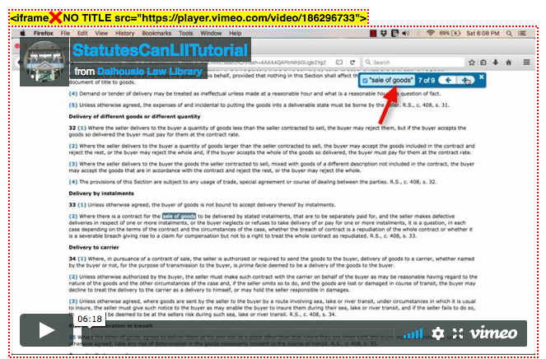

#### Font Type, Size and Styling

##### Importance and Users Impacted

Best practice is to use sans-serif font types, and a font size 12 point or above. All CSS files should be double checked to ensure that pixels (px) is not being used for text. Font sizes should be at a minimum of 100% or 1.0 em (or rem). As well, italics and bold should be used sparingly, again following best practice.

This will help make the text easier to read for the majority of users, including elders and people with visual disabilities, such as low vision, and/or cognitive, neurological, intellectual and/or learning disabilities.

##### Findings

**Acadia Biology **PRIORITY\*\***

This web page is using pixels in the CSS file, and these all need to be replaced with percentage, ems or rems. Examples of pixels being used are shown below.

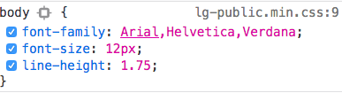

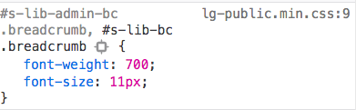

Note that very small text is present in the footer area, as shown in the screen print below. This needs to be 100% or 1 em (1.1 if possible) minimum.

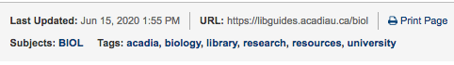

**Acadia Business **PRIORITY\*\***

This web page is using pixels in the CSS file, and these all need to be replaced with percentage, ems or rems. Examples of pixels being used are shown below.

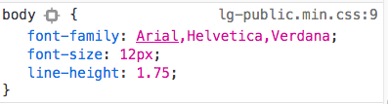

There was also one section that used a bright colour and italics, as shown in the screen print below. This should be remediated, as the colour should be changed to black to match the rest of the page, and the italics should be deleted. If this link needs to stand out, then bold should be used for it.

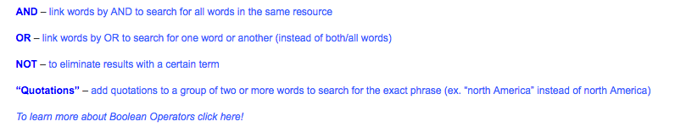

The tester with low vision, who uses magnification found that important information needed to be highlighted more on this page, with bold.

“Due to my disability I don’t read any text If I don’t have to as it is more challenging to do, so I didn’t like how under the heading “Journal Collections for Business” there was a note that said items marked with the Acadia crest were only for the Acadia community. This text is easy to skip over and doesn’t look important. I didn’t read it until after I had attempted to access the Science Direct portal. Perhaps making this a bold or having it stand out in another way would be helpful…My minor gripe is that if there is important information please bold it or enlarge it so that its easier to see.”

**Acadia Kinesiology **PRIORITY\*\***

This web page is using pixels in the CSS file, and these all need to be replaced with percentage, ems or rems. Examples of pixels being used are shown below.

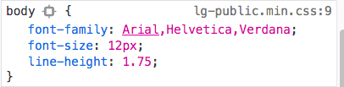

**NSCC *SECONDARY PRIORITY\***

This web page uses 14 point for the main text areas, which should be kept as it is over the recommended minimum. However, pixels are being used for the text in the CSS file. These need to be replaced with percentage, ems or rems. Examples of pixels being used are shown below.

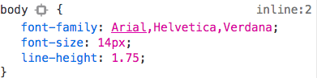

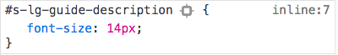

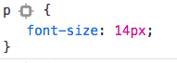

**MSVU **PRIORITY\*\***

The CSS code seems to display a font size of 1.2 em, which is over the recommended minimum. However, the main text areas appear very small. The CSS file should be re-examined to find out why this is happening, as the text may be hard to read for many users.

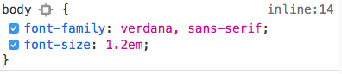

Note that very small text is present in the footer area, as shown in the screen print below. This needs to be 100% or 1 em (1.1 if possible) minimum.

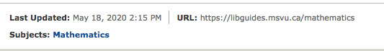

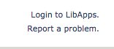

**Dal Aboriginal Law **PRIORITY\*\***

This web page is using pixels in the CSS file, and these all need to be replaced with percentage, ems or rems. Examples of pixels being used are shown below.

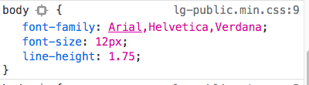

Note that very small text is present in the footer area, as shown in the screen prints for MSVU and Acadia Biology above. This needs to be 100% or 1 em (1.1 if possible) minimum.

#### Headings

##### Importance and Users Impacted

Headings on web pages should be styled differently from the main text content for sighted users, using bold, larger text sizes, etc. Headings also need to be noted in the HTML code, so that screen reader users who are blind, Deaf-Blind or have low vision, can also access them. These are crucial invisible signposts for these users, as they indicate the overall structure of the page, and give an idea of the overall page content as well.

Headings are given numbers to indicate their importance. A Heading 1 (<h1>) would indicate the main title on the web page, a Heading 2 (<h2>) would indicate a major section, etc. The numbers should be used in order, as this helps screen reader users better understand the overall structure of the page.

##### Findings

**Acadia Biology **PRIORITY\*\***

On this web page there are many headings. Almost all of them are used as per best practice. However, there is one problem that needs to be remediated. There are two main titles, indicated by Heading 1s (<h1>), as shown in the screen prints below.

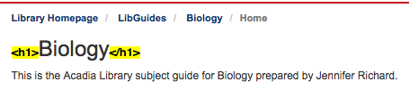



There should only be one Heading 1 present on each web page. That heading should be the main title of the page, and not the general title of the web site. So the Heading 1 (<h1>) attached to the ‘Subject Guides: Vaughn Memorial Library’ must be removed. Instead only the main title of the page should keep the Heading 1 designation.

**Acadia Business **PRIORITY\*\***

Please see the Acadia Biology section, as this web page needs the same remediation.

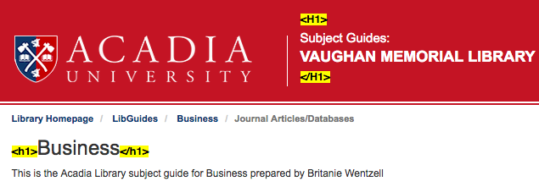

**Acadia Kinesiology **PRIORITY\*\***

Please see the Acadia Biology section, as this web page needs the same remediation.



**NSCC**

No issues noted.

**MSVU**

No issues noted.

**Dal Aboriginal Law**

No issues noted.

#### Images

##### Importance and Users Impacted

All images used in the website, including photographs, shapes, illustrations, maps, charts, etc., should be accessible to all readers. For screen reader users, images must be marked in the html code, as either important or non-important.

Screen reader users want to use their time accessing important images, so non-important images, such as those used for decoration, are marked with code that makes them invisible, so the screen reader user can ignore them. A null, or two quotes, is put in the alt attribute to signify this, such as alt="".

Important images may be regular images, images with text, and/or linked images. They add to the content, and/or context, of the text in some way. For important images, a short or long alternative text (alt) description must be provided that describes the image, and its importance.

If the image can be described in under 40-50 words, then this description is put in the alt attribute area. For example, <img src="images/importantimage.jpg" alt="explain the image as briefly as possible and only use a maximum of 40-50 words" />. If the image requires more description, the different techniques must be employed. Note that if an image is described in the text above or below it, and/or it is described in the caption, it likely still needs an alt text description to ensure all readers can access the information in it.

##### Findings

**Acadia Biology **PRIORITY\*\***Two image issues were noted on this web page. First, there were no alt attributes noted in the social media image area. Alt attributes must be added to each of them, along with descriptive text. Technically, since there is no text that is being linked, an aria label could be added to each of them with the same description as the alt attribute text.



The second issue noted was generic text descriptions used for the three images in the New Library Books Section. All three descriptions need to be changed, so they are more descriptive. Example wording could be ‘Book Title X cover art’.

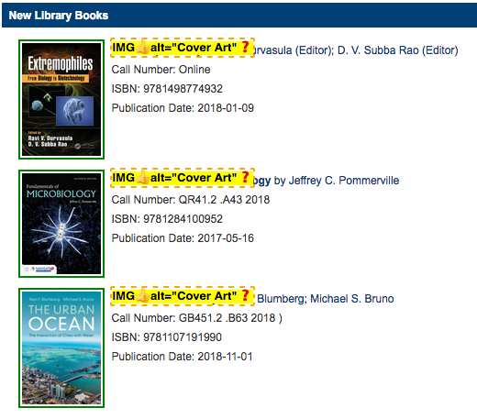

**Acadia Business**

No issues noted.

**Acadia Kinesiology **PRIORITY\*\***

There were two image related issues noted on this web page. First, descriptive alt text needs to be added to the archivist’s picture. The alt could be ‘Wendy Robichaeu’s headshot’. A second image also needs descriptive alt text added to it, instead of a null alt (alt=””). The image used for the PowerPoint download must be described as fully as possible, noting all the text that is present in that image. This is vital, because there is no other way to know what is in the image, but also what is being linked to as well.

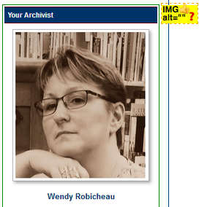

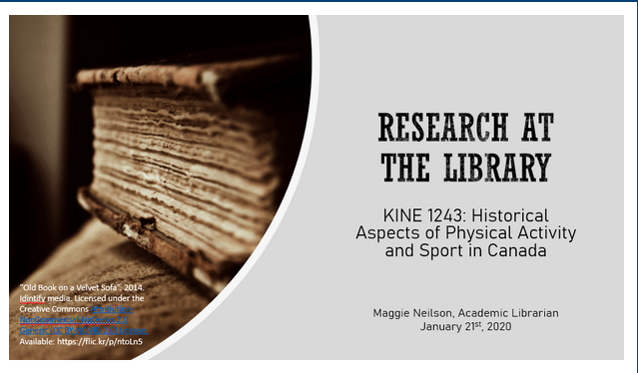

**NSCC **PRIORITY\*\***

There was one image related issue noted on this web page. The top banner image, which is very important, needs more descriptive alt text added to it. Currently, it is ‘Banner Image’, which is generic. It should be changed to ‘NSCC Libraries’, so all users know what the institution and department name is, when they come to the web page,

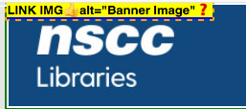

**MSVU **PRIORITY\*\***

There was one image related issue noted on this web page. The top banner image, which is very important, needs descriptive alt text added to it. Currently, there is no alt text attached to it. An alt attribute needs to be added and it needs to be descriptive, for example, ‘Mount Saint Vincent University Library & Archives’. As well, it should have an ARIA label added to it, to provide information about the link content.



**Dal Aboriginal Law **PRIORITY\*\***

There were two important image related issues noted on this web page. The top banner image, which is very important, needs more descriptive alt text added to it. Currently, it is ‘Banner Image’, which is generic. It should be changed to ‘Dalhousie University Libraries’, so all users know what the institution and department name is, when they come to the web page,

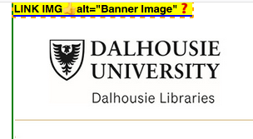

The second image has no alternative text, and this must be remediated. It is highly recommended that this image be given a short description in the alt attribute, such as ‘How to Cite a Statute is described in the text’. Then a text description needs to be added after the image, describing the process that is noted only on the image. This will help all users, including those without sight and those with cognitive, neurological, learning and/or intellectual disabilities.

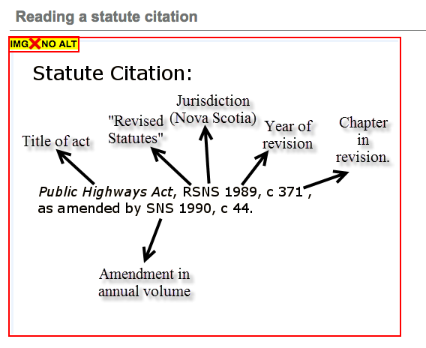

#### Tables

##### Importance and Users Impacted

Tables should only be used in web pages when they hold data. They should not be used for design or layout purposes. Users, particularly screen reader users who are blind, Deaf-Blind or have low vision, who can’t see the content in the tables, expect data to be in them. So, when they are used for layout and design, it is a confusing experience.

##### Findings

**Acadia Biology**No issues noted.

**Acadia Business**

No issues noted.

**Acadia Kinesiology**

No issues noted.

**NSCC**

No issues noted.

**MSVU**

No issues noted.

**Dal Aboriginal Law**

No issues noted.

#### Page Titles

##### Importance and Users Impacted

Descriptive and unique page titles, which have correct spacing and grammar, should be present in every html file at the top, in the <title> tag. These are used as the title in the browser tab, and as the title when a user bookmarks the web page. These page titles are also usually the first thing screen reader users hear when they come to a page. The screen reader software usually reads the page title first, before any other content, so it is a very important component.

##### Findings

**Acadia Biology **PRIORITY\*\***Page titles exist, and no issues were noted. However, see the issue of the main titles noted for Acadia Business and Dal Aboriginal Law, because the same issues apply here. They should be remediated, and then the page titles (<title>) may have to be adjusted accordingly.

**Acadia Business **PRIORITY\*\***

Page titles exist, and no issues were noted. However, main titles on all web pages need to be reconsidered, and once they are remediated the page titles (<title>) may need to be adjusted accordingly.

One example is the Journal Articles/Databases subpage in the Business LibGuide section. This page, along with every other page in the Business section, has the same main title of ‘Business’.





All users need more descriptive main titles (<h1>), and these on all web pages must be remediated. In this example, the main title in both pages is ‘Business’. This should be changed so it reflects the page the user is on, and then the page title should echo it.

CURRENT

Business

RECOMMENDED

Business- Journal Articles/Databases

**Acadia Kinesiology **PRIORITY\*\***Page titles exist, and no issues were noted. However, see the issue of the main titles noted for Acadia Business and Dal Aboriginal Law, because the same issues apply here. They should be remediated, and then the page titles (<title>) may have to be adjusted accordingly.

**NSCC **PRIORITY\*\***Page titles exist, and no issues were noted. However, see the issue of the main titles noted for Acadia Business and Dal Aboriginal Law, because the same issues apply here. They should be remediated, and then the page titles (<title>) may have to be adjusted accordingly.

**MSVU **PRIORITY\*\***Page titles exist, and no issues were noted. However, see the issue of the main titles noted for Acadia Business and Dal Aboriginal Law, because the same issues apply here. They should be remediated, and then the page titles (<title>) may have to be adjusted accordingly.

**Dal Aboriginal Law **PRIORITY\*\***

Page titles exist, and no issues were noted. However, main titles on all web pages need to be reconsidered, and once they are remediated the page titles (<title>) may need to be adjusted accordingly.

One example is the Legislation subpage in the Aboriginal Law LibGuide section. This page, along with every other page in this section, has the same main title of ‘Aboriginal Law’.





All users need more descriptive main titles (<h1>), and these on all web pages must be remediated. In this example, the main title in both pages is ‘Aboriginal Law’. This should be changed so it reflects the page the user is on, and then the page title should echo it.

CURRENT

Aboriginal Law

RECOMMENDED

Aboriginal Law-Legislation

#### ARIA Code

##### Importance and Users Impacted

ARIA code is used primarily by screen reader users, and to a much lesser extent by voice recognition users. This code aids in navigation of web pages, and is sometimes required by WCAG. ARIA code has been mentioned elsewhere in this report, such as aria-label in the Calendar Section. Note that ARIA should never be used **instead** of HTML code, unless there is no other option.

There are different types of ARIA code that can be used on web pages. One ARIA element is landmarks, or roles, and these should be used on all web pages. Landmarks are invisible signposts in the code that are used by many screen reader users, and some voice recognition users.

With HTML 5, we can add important landmarks to note areas of the page in the code, such as <header>, <nav>, <main> and <footer> (a minimum should be header, footer and main). This code should also be mapped to ARIA roles, such as role=”banner”,role="navigation", role="main" and role="contentinfo", for full functionality. It is also recommended that the role ‘form’ be used as well.

It is recommended that the code include full landmarks to indicate page layout. This was added to the recent update to WCAG 2.1. Even though these are considered at the ‘gold level’, it is recommended they be included in the code.

ARIA can also be used to alert the user to potential changes or dynamic areas. For example, in accordion drop downs, they have the capability of changing from closed to open, and ARIA code should be used to note that to those users.

##### Findings

**Acadia Biology **PRIORITY\*\***This web page (and search results page) has three roles, two navigation and one search, and one HTML header. The full set of roles should be present, so banner, main and contentinfo should be added to the corresponding areas. See also Dal Aboriginal Law for use of aria-hidden for the back to top icon.

**Acadia Business **PRIORITY\*\***

See Acadia Biology for remediation of roles, and Dal Aboriginal Law for use of aria-hidden for the back to top icon.

**Acadia Kinesiology **PRIORITY\*\***

See Acadia Biology for remediation of roles. See also Dal Aboriginal Law for use of aria-hidden for the back to top icon.

**NSCC **PRIORITY\*\***

See Acadia Biology for remediation of roles (note no HTML 5 header tag was used here). See also Dal Aboriginal Law for use of aria-hidden for the back to top icon.

**MSVU **PRIORITY\*\***

Only the Search role has been used on this site. See Acadia Biology for remediation of roles, and add navigation roles to it. As well, in this web page there are more blocks of information and search areas on the right side. These have not been given a role.

The blocks with text should be given the role of aside, and the search blocks should technically be given the role of search as well, although some consultants argue only the main search area should be given the search role. See also Dal Aboriginal Law for use of aria-hidden for the back to top icon.

**Dal Aboriginal Law **PRIORITY\*\***

This site has one search and one navigation role present. See Acadia Biology for remediation of roles. Many other roles are used, such as menu, presentation, etc.

The role of menu should be removed. In this case, in my opinion, it is not needed and could cause issues for some users. The role navigation is present, and this area is a proper list, and that should suffice.

In the Links & Tasks area, there is ARIA used, because of the ‘toggling’ of two tabs in this area.

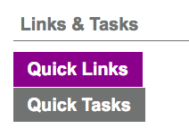

ARIA should be used here, however in my opinion it needs to be remediated.

There are tab roles present, but no tablist role is present. All tab roles must be contained in a tablist role, so the screen reader users without sight know how many tabs are present. In the code, role=presentation was used, but in my opinion aria-selected=true and false should be used, not the presentation role, as they are more accurate to the situation.

There are tabpanel roles present, and they are correctly used. However, each tab role should have an aria-controls attribute with an ID reference of the tab panel it controls. Finally, it is also recommended that an aria-labelledby be added to the tabpanel roles that points to the tab control ID. This is done so that each tabpanel is given a unique name.

One last item related to this area, is that the list code has errors due to the use of role presentation. This should be remediated, so the list code has no errors present in it.

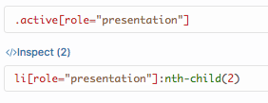

One item noted by the tester with hearing, mobility and perception disabilities relates to this Quick Tasks area, although it is not ARIA related. They found issues with this area and noted:

“The Quick Links area is not noticeable that it was meant to be under the heading as it seems like it would direct me somewhere else. After noticing the difference after accidentally clicking Quick Tasks that I notice the list was there. One item on the list is “WestlawNext Canada…as previously mentioned, the list was not noticeable leading to confusion. There is a list once I switch to Quick Tasks which I then learned the Quick Links, the section just was not clear.”

One other item to mention is that aria-hidden=true was used on the top banner, back to top icon and print icon. This should not be used on any focusable element. In the case of the banner, since the next text link down is Dalhousie University Libraries, with the same information gained as the logo banner area, then technically this can stay in place. It is still recommended that aria-hidden=true is not used in this manner, This hidden code was used on the back to top link and print icons (except MSVU), and these should also be reconsidered.

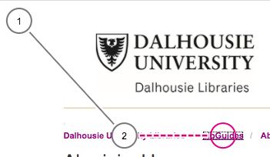

#### Search Mechanism

##### Importance and Users Impacted

Form elements, such as search mechanisms, must be accessible for all users, including screen reader users who are blind, Deaf-Blind or have low vision. Labels should be used on all form elements. Labels tell the user what the field is called and/or what to add in there, and these should link to the text next to each form item. So, the Username text next to a form element would match the Username label attached to that element in the code. As well, the label and ID should be the same, as in <label for="searchbox"> and <input id="searchbox">.

If a visible label can’t be added to the form, search box, etc., then one has to add code for viewers without sight. The most common method to add invisible label like information to the code today is to use aria-labelledby. It isn’t perfect by any means, but provides some information to screen reader users. Labels are not required for image, submit, reset, button, or hidden form controls.

Search buttons should be used, and they should use the <button> code, and not other code. If the <button> code is not used, many screen reader users without sight, and voice control users with sight may encounter severe issues with the use of that search input feature.

Many developers use placeholder text in search boxes to alert the user to how they can use that search or form element. It can be useful for voice control users, if it is paired with a label that has the exact same text. Although this is problematic, because that label text disappears as soon as words are entered the box, making it hard to reuse that search box in some situations. Users have the least issues when a visible label is used, without placeholder text.

While other consultants may disagree, it is recommended that placeholder text not be used in search or form boxes. Placeholders can cause many issues. This field may look ‘pre filled’, and it disappears when activated, which may cause confusion for elders, people with mobility disabilities and/or viewers with cognitive disabilities. As well, it doesn’t provide the same information to screen reader, or voice recognition, users that labels do, and finally on a device keyboard the label is better, because it provides information without erasure.

**Acadia Biology *SECONDARY PRIORITY* (Optional)**There is one search box at the top of the page that is problematic, and needs remediation.



The <button> tag has been used for the Search button, and the label and ID match, as is best practice. However, the search box itself can be remediated (although this can be optional, see below). It currently has a label, which is required for form input boxes, but it is invisible:

<label class="sr-only" for="s-lg-guide-search-terms">Search this Guide</label>

The developers have made the label invisible, so that only screen reader users without sight can access it. The placeholder text in the search area is “Search this Guide’, for users with sight. This box was successfully used by the voice control user, because the invisible descriptive label happened to be the exact same phrase as the placeholder text, “Search this Guide’. In this instance the search area was usable for both screen reader and voice control users. However, it is still recommended that if possible, a visible label be used, and that the placeholder text be removed.

**Acadia Business **PRIORITY\*\***

This page has a search box at the top and another search area halfway down the page. For the top right search box, please see the Acadia Biology section for more details on the same search mechanism.

The second search area is problematic, and needs to be remediated.

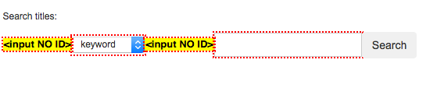

The <button> tag has been used for the Search button, as is best practice. However, there is no ID or label on either of the two search components, and these need to be remediated. See the Acadia Biology section on remediation options in terms of visible labels and placeholder text options.

**Acadia Kinesiology *SECONDARY PRIORITY* (Optional)**

This page has a search box at the top right. Please see the Acadia Biology section for more details on the same search mechanism.

**NSCC *SECONDARY PRIORITY* (Optional)**

This page has a search box at the top right. Please see the Acadia Biology section for more details on the same search mechanism.

**MSVU **PRIORITY\*\***

This page has a search box at the top right. Please see the Acadia Biology section for more details on the same search mechanism.

There are many other search areas on this page and all need remediation. The second one is the EBSCO Search area.

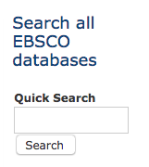

The <button> tag has not been used for the Search button, so this needs to be added. As well, there is an ID but no label for this search component, and this need to be remediated. There is a label found for the Peer Review box. This search area could not be used successfully by the voice control user, due to a lack of visible label (or invisible one that matched placeholder text). See the Acadia Biology section on remediation options in terms of visible labels and placeholder text options.

The third search area is the ProQuest one, and it has the exact same issues as the EBSCO search area above.

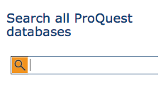

The tester with the hearing and visual disability, who used a screen reader noted an issue with the MSVU Mathematics ProQuest database search area. This tester did not find this component, because it is lacking form code needed for screen reader users. See the Form Section labels area.

“Voiceover- there was no ProQuest database as I tabbed. However, I noticed when I pressed Shift+ Tab to go back, it said “leaving ProQuest” so I guess there was ProQuest and it just wasn’t tabbable. Jaws- there was no ProQuest. I didn’t shift tab here.”

As well, an accesskey (accesskey="4") has been used in the code near the ProQuest box. These have not been recommended for use for many years, so it should be removed. Another note about this search box is that two terms can be parsed out of this one box. This search area was not successfully used by voice control or screen reader users, and must be remediated. One added note is that the search button mechanism should be replaced by a more traditional one, as it can’t be used by many users at this time.

The last search box on the page is the Google Scholar search area.

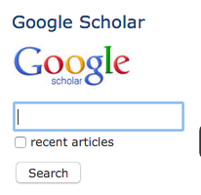

This search area has the exact same issues as the EBSCO and ProQuest search areas above. There is no <button> used, although there is an ID (‘q’) but no labels are present. An ID is used for the search box, although it would not make sense to a user (what does q mean?). A label is required here.

As well, the recent articles checkbox also has an ID and name, but they are ‘as_ylo’. This is not a phrase that would make sense to any screen reader or voice control user, and this should be changed. The ID and name should read as ‘Recent Articles 2009 and above’.

One note on another feature on the page that was given the <button> code. The button code was used for the drop down links in three areas of the page, and one example ‘Linking Instructions’ is shown below.

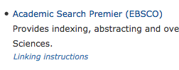

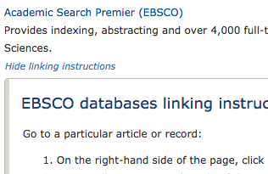

While the use of the button code was technically correct, because the link activated or toggled an interface area, it is highly recommended that changes in the design, layout and styling of this drop down mechanism and area be made. The voice control user could not activate the link on iPhone, likely due to the coding.

The tester with mobility and cognitive disabilities, who uses text to speech software could not activate the link with their technology:

“For some reason, I highlighted the linking instructions to be read with my text to speech reader, but it skipped it and went straight to reading the entire page, starting at the very beginning. I wonder If its b/c the linking instructions are a “toggle” or additional to this page. This needs to change. I was able to access the instructions, but I can’t read it using my software.”

As well, sighted users may assume that this link would go to a document, or another page, and not open up a drop down. Thus, this drop down area should be changed, so it is accessible for all users, and so that it looks different in a visual way from regular links. Once that is done the text used should also be changed. There are three instances of ‘linking instructions’, and they should be made more specific, such as ‘Academic Search Premier Linking Instructions’.

The tester with low vision, who uses magnification, found it hard to find the multiple search boxes on the MSVU Mathematics page on the iPad. This design should be reconsidered, for better use on mobile and tablet devices.

“I scrolled down the page and discovered that there are multiple search boxes, however i would not have known this had i not scrolled down. This would be challenging if i were looking specifically for those search options. Perhaps moving these fields into a separate section near the top of the page would help them be more easily accessible.”

This tester also had major issues with the EBSCO search box, but could use the other two search boxes on the right side without issue. This search mechanism should be remediated, as noted earlier, and tested again for issues.

“The EBSCO search button did not work so i tried to search by hitting the enter key. The page reloaded but did not bring up any search results. It simply reloaded the main page.”

The tester with the hearing and visual disability, who used a screen reader noted an issue with the MSVU Mathematics Google Scholar search area. This relates to the other issues noted above.

“Voice over- I found Google scholar ok but there was no search box to search. I pressed enter on the google scholar link and it brought me to the Log In page. Jaws- I found Google scholar ok, there was no search bar. I just clicked the link and it brought me to the Login page.”

**Dal Aboriginal Law **PRIORITY\*\***

This page has a search box at the top right. Please see the Acadia Biology section for more details on the same search mechanism.

There is a second Search area on the page in the middle left side of it. It could not be used by voice control users, or screen reader users, and must be remediated. The <button> tag has not been used for the Search button, and this needs to be added. There is also no ID or label on the search component, and these need to be remediated. See the Acadia Biology section on remediation options in terms of visible labels and placeholder text options.

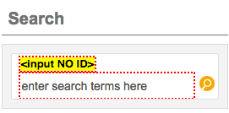

**Acadia Scholar Landing **PRIORITY\*\***

#### Search Results

##### Importance and Users Impacted

Search results must be accessible, and easy to use by all users, whether they have a disability or not.

##### Findings

**Acadia Biology **PRIORITY\*\***

The ‘Search System’ and ‘Search This Group’ button cannot be activated by voice recognition users, nor can the sort (relevance) mechanism. These must be remediated. When the tester with low vision, who uses magnification, encountered the ‘Search the System’ button, they related the following:

“Searching the system worked well, although I was unsure of what exactly it meant. It looked like a search box where I was supposed to type in text, however it turned out to be a button. That was confusing. Perhaps making it another colour than white would make it stand out as a button rather than a search field.”

The consultant also points out that text should be added to explain what ‘search the system’ means, versus the search that was done (and the user is on the results page where they can activate the search the system).

As well, it is recommended that the filter sections be given headings (see Headings Section) for ease of use. The reason this is recommended is that there are 173 clicks needed of the tab key to get to the filters. The headings in this case would provide a short cut mechanism for viewers without sight, or low vision, who use screen readers.

See the issue noted by the text to speech tester in MSVU Mathematics, and issues noted by the tester with low vision and the tester with the hearing and visual disability in the Acadia Kinesiology section. Finally, note the issue in the Headings Section, regarding the Heading 1 main titles, and the search box without a label issue in the Search Mechanism Section.

**Acadia Business **PRIORITY\*\***

See the Search System and sort mechanism issues in Acadia Biology.

The testers were asked to test the A-Z Journals search on this page. The tester with ADD noted that on the search results page for the Acadia Business A-Z Journals search could be made easier to use. Currently the blue ‘License Information’ stands out more than the item, such as ‘Economics’ below.

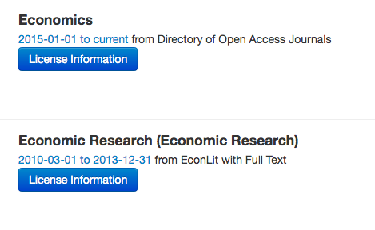

The tester felt, and the consultant agreed, that the heading was far more important than the licensing information, when doing initial searches. Thus, it is recommended that the blue license box not be highlighted in this way, so the heading stands out.

Another tester, who is older with ADHD, noted that this area had ‘bountiful’ results.

“At first, they didn’t. make sense, I thought huh, boring titles of articles, then I thought they were subject headings. .Then I realized I what I had done was a search for the titles of journals and then it made sense. Truthfully as a student I would be very overwhelmed trying to refine my search by journal title. Also, I didn’t know what the blue hyperlinks stand for or represented – I had to revisit them and then looking the third time realized they were actually date ranges (presumably of subscription issues available) and where they could be found…”

The A-Z Journal area did not work with the Mac VoiceOver screen reader, which was used by the tester with hearing and visual disabilities. The tester said:

“My page did not change so I did not get any results. The option is not functioning.”

The tester then emailed the consultant with questions about this function, went back and it will still problematic:

“…[the button] It just didn’t tell me whether it had been pressed and that it was entering a drop-down menu (if it was). After I pressed the search button, it took some time (longer than the usual) to load the search page.

“Using Mac -Voiceover, after I heard that all the results were in time frames, I decided to zoom in because I wanted to know if that was all that was there. I found out, that there are actually journal titles like “” Economic Cybernetics”. This was a surprise because voice over did not read the titles to me. Therefore, I suggest that this page needs to be fixed to read the articles. The A to Z page needs to be fixed too to say,” Entering A to Z journals menu” plus the page should not take so long to load.”

“Using Jaws, I was able to search easily by tabbing. It gave me results but once again, it read only time frames to me and the link for licensing information. It didn’t read the article titles (I know there are article titles because I zoomed in on my Mac). The article titles need to be fixed. They need to be tabbable”

It is recommended that these issues be considered, and the code checked to see if more can be done to solve these issues. One possible fix is to have every single item in the search results start with a Heading (<h2>). This might help screen reader users go through results without issues.

See the issue noted by the text to speech tester in MSVU Mathematics, and issues noted by the tester with low vision and the tester with the hearing and visual disability in the Acadia Kinesiology section

**Acadia Kinesiology **PRIORITY\*\***

The tester with low vision, who uses magnification, found:

“…The search results are cluttered and contain a lot of text (a paragraph of text for each result). This required me to magnify the screen to read through each result. Two of the three results were from the same page and so the titles were the same (I.e both results began with “In Library Collections on KINE 1243 - Historical Aspects of Physical Activity and Sport in Canada by Maggie Neilson Subjects KINE”.   
  
This made it challenging to differentiate the two results which contributed to the challenge of finding which result is most relevant. To overcome this barrier I would suggest just one search result per page even if there is more than one mention of the query term on that page. This will avoid duplicating the pages appearing in the search results.”

On the search results page, this tester couldn’t sort, as they related:

“ I could not sort the results by page name. The default was “sort by relevance” and when I selected “sort by page name” on the drop down menu the page wait indicator (the spinning circle) seemed like it was doing something, however when the page refreshed it was still sorted by relevance.”

This tester also noted issues with the filters present on the search results (search system) page, but these would be considered minor, because they were able to circumvent them.

“I struggled to find the filters initially as they are located at the bottom of the page. Especially when zoomed in, it is challenging to have to scroll all the way down the page to find these. The filters worked well and I could tell that it was working because the waiting indicator (spinning circle) would spin and then the results would refresh. I had no issues with the various filters and did not experience accessibility issues.   
  
One minor point I’d make is that when you filter by multiple items the numbers next to the results don’t work. For example if I filter by author (I.e Ann Smith) it says there are 43 articles. If I then also want to filter by subject (I.e ENGL) the number to the right of ENGL says 16. I expected this to mean that there are 16 articles by Ann Smith on ENGL, however the results refreshed and showed zero articles. This isn’t an accessibility issue, however it is a minor potential improvement that could be made.”

The tester with the hearing and visual disability, who used a screen reader noted issues with one screen reader, and not the other one they used for testing. This can happen, as each screen reader is different, and reacts to pages and elements differently. These suggestions should be considered if possible, as use of iPhones, iPads, etc. is increasing.

“With Mac Voice over The results were confusing. I heard “1 of 5 to 5 of 5” and I wasn’t sure if this was the numbering for each article. It also should have said “Author” before saying “Maggie Nelson” so I would know it was Maggie Nelson that was the author (if she is). After it read the article titles. I heard the “2 of 5”, “1 of 5” to “5 of 5” again. I’m assuming this signifies page numbers for the search results. this is confusing. I suggest it says “Page numbers: before it starts reading out the numbers of the pages. Using Jaws, the search results made sense. It let me know that I was on the first page. I found myself quickly in the article titles by tabbing.”

They mentioned another issue that related to the Search System button, and it relates to the results they noted above. The tester with the hearing and visual disability, who used a screen reader, noted that when they tried to Search the System different things happened, with the two screen readers. This illustrates the confusion that come about with web page construction. The code should be evaluated by the developers to see if the paging can be improved.

“Voiceover-I could search the system and it was clearer that the “1, 2, 3, 4, 5” at the top of the page were page numbers. However, at the bottom of the page, it started reading “1. 3 of 9, 2. 4 of 9, 3.5 of 9, 4. 6 of 9. 5. 7 of 9.6. 8 of 9. 7. 9 of 9”. I honestly don’t understand what this means. Using Jaws, I could search the system. The pages were defined.”

This same tester, with the hearing and visual disabilities, who used a screen reader, tried to sort results. With their experience below, it is suggested to perhaps add text to that area, to make it clearer for these users.

“With Mac (Voice over) No, I don’t understand how the pages are arranged. I don’t know what the “less than less than” means. Using my Jaws, it is clearer what the pages are, but I don’t hear section to sort by page name.”

When this tester tried to go to page 4 of the results, they noted their experience. It is likely that this is a screen reader issue, but the code should be investigated to see if changes can be made.

“With Mac (Voice over), this was a very confusing experience. I started to have a headache while trying to figure out which one was page 4. this is because it says “2. 4 of 9” and after tabbing a few more times, it says “4. 8 of 9”. I tabbed to the bottom of the page to try to find some clarity, but the page numbering was as confusing as the top of the page. I went to both pages and I found the results by tabbing. The problem is I can’t tell what page I’m on. It’s quite frustrating. Using Jaws, I can find page 4 fine. It gave me results I could tab to fine.”

The tester with the hearing and visual disability, who used a screen reader, noted an issue with the filter area. It is likely that this is a screen reader issue, however the code should be investigated to see if changes can be made.

“With my Mac (Voice Over), I tabbed and there was nothing that said filters. All I heard was that after all the article titles were read, the names of the courses started being read like Geology (4). I don’t even know what the numbers mean. To be honest, I had to zoom into the screen with my low vision because I wanted to find out where the filters were. A lot of codes were being read that I didn’t understand.”

“Using my Jaws, I had to tab through all the journal articles first, then I got to the filter section. It actually read the headings “Filter by Subject, “Filter by tags”. when I selected on a filter, it would not bring me to the new results immediately, rather I would have to tab through the rest of the filter options, get to the bottom of the page, then go back up to view the results.”

“Using my Mac (Voice over)…the filters section should be an option in the navigation section at the top. I shouldn’t have to go through all the article titles before I can filter (even with the item chooser function). At the top of the page, it should say filter by subject and filter by tag and when I press enter on either of the options, it should take me to the search results (article titles) immediately.”

“Using Jaws, the only thing I would really say needs improvement are the filter sections, they should be an option at the top of the page and once a filter is chosen, it should immediately bring you to the journal article results rather than having to tab through the rest of the filters, down to the page and back up.”

The tester with ADD also experienced issues with the Acadia Kinesiology results page. They could not search by Page Name, and they had no success with any of the ‘Sorted by’ options. This was an issue for other testers, who used technologies, as well. This tester also noted other issues with the Filter area:

“I found that “Filter by Subject” was not entirely user friendly. The subjects listed under “Filter by subject” used abbreviated names and I am not familiar all the abbreviations. For example, I do not know what “EAP” stands for.”

See the Search System and sort mechanism issues in Acadia Biology. See also the issue noted by the text to speech tester in MSVU Mathematics.

**NSCC **PRIORITY\*\***

The ‘Search System’ button cannot be activated by voice recognition users, nor can the sort (relevance) mechanism. These must be remediated.

When this page is magnified by 400%, and when on small screens, the results go off the page. This is noted with the URLs, and it should be remediated so users don’t have to scroll.

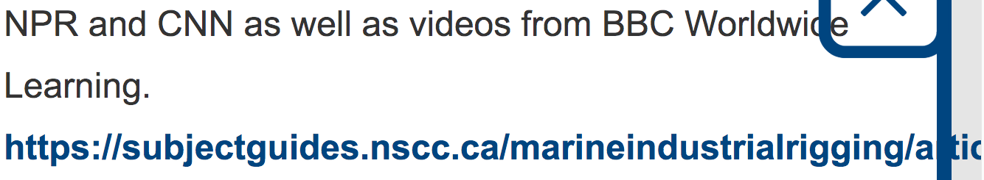

The tester with autism noted that on the search results page from the NSCC Accessibility search, they had access to the sort (Page Name, etc.) feature, but the sort by Page Name did not work as expected. This should be explored to see whether this was a one off issue.

The tester with autism noted that when they went to that search results page, and clicked ‘Search Group’, the same number of items came up, which was a bit confusing. It got more confusing, because they clicked ‘Search System’ (the button changed from Search Group to this once Search Group was activated) and were shown many more listings. It is recommended that this search page be reconsidered, especially in terms of the Search Group option. Text would make it clearer what that function will do with the results. NOTE: This applies to other pages that use this same search results mechanism.

The tester with the hearing and visual disability, who used a screen reader noted an issue with the search results (which also apply to all other sites). They searched for the term ‘article’ in the main search bar. They got to the results, and they didn’t make sense to this user. They felt that the results were not clear, in terms of categories.

They thought they would get ‘articles’, but instead got ebooks, databases, etc. The confusion could have been due to the term used. However, these results pages should be considered in terms of explaining how the results are organized. This could be accomplished with a paragraph of text at the top of the page to explain the layout of the results area. This is what the tester noted:

“Using my Mac- voice over, No, the results did not make sense to me. The results were just links to subject guides, eBooks, etc. there was no actual article. Maybe it should have explained why there was no actual article or said no results. Using Jaws, No, it did not make sense to me. The results were just links to subject guides, databases etc.”

See the Search System and sort mechanism issues in Acadia Biology. See also the issue noted by the text to speech tester in MSVU Mathematics, and issues noted by the tester with low vision and the tester with the hearing and visual disability in the Acadia Kinesiology section.

**MSVU **PRIORITY\*\***

The ‘Search System’ button cannot be activated by voice recognition users, nor can the sort (relevance) mechanism. These must be remediated. As well, voice users could not get the A-Z Database List tab to function, so they couldn’t access that content. As in the sites above, the filter area needs headings, see Acadia Biology.

One major issue noted was that the voice user on Apple iPhone could not open the hamburger menu to access the main search bar. This bar should be relocated so it is present on the web itself.

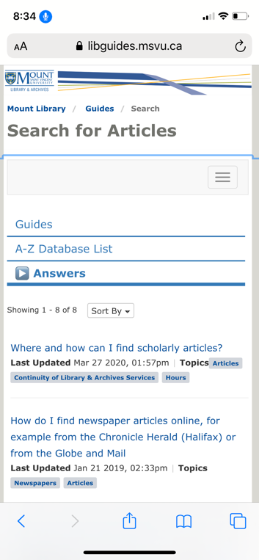

The tester with mobility and cognitive disabilities, who uses text to speech software, experienced major issues with the search results page:

“Unfortunately, text to speech software cant read the “Answers” or “Guide” or “Database list” tabs. Not sure why, it completely just skips it.”

The tester with low vision, who uses magnification, found it the search results from the main search box hard to read:

“The search results were ok however there were big blocks of text under each result. This made it challenging as I could not as easily find the most relevant results without magnifying the screen and reading through each result.”

The tester with the hearing and visual disability, who used a screen reader noted major issues with the results page as well. The sort function does not work for some screen readers, and the results were confusing, and need explanatory text at the top of the page. It may be confusing to viewers without sight that the results can be not articles, but subject guide links.

See the Search System and sort mechanism issues in Acadia Biology. See also the issue noted by the text to speech tester in MSVU Mathematics, and issues noted by the tester with low vision and the tester with the hearing and visual disability in the Acadia Kinesiology section.

**Dal Aboriginal Law **PRIORITY\*\***

See all the issues noted in all the sites above. As well, the tester who used keyboard only navigation, with the tab key, could not use the ‘Sorted by’ mechanism. This must be changed so they can activate it with their tab key.



#### Live Help Widget

All widgets need to be accessible for all users. Live Help is a widget that allows the public to communicate with librarians through a web page widget.

**Novanet Live Help **PRIORITY\*\***

**CBU Live Help **PRIORITY\*\***

**Dal Live Help **PRIORITY\*\***

There were many issues noted with all three of the Live Help widgets. The issues were the same, so these have been documented for all three interfaces.

The widget cannot be used with voice control on iPhone, because there is no way to get the text input area to activate.

The LiveHelp is located in an iFrame. This needs a descriptive title added to it. See the iFrame Section for more details.

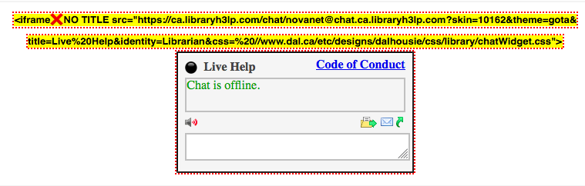

The widget has a Heading 1 of Live Help at the top of it. However, the Code of Conduct link is also part of the Heading 1, and this is incorrect use of a heading tag. The Code of Conduct link should be taken out of that heading.

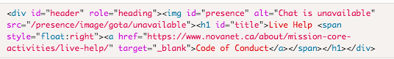

As well, an aria-level may be needed in this area. This should be investigated once the Heading 1 fix is made.

There were issues noted with the formatting of the Live Help, where the code of conduct link obscures the text area, when on a screen of 320 x 568 in Portrait mode. This should be remediated.

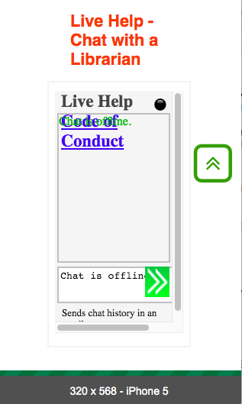

Similar issues were noted on an iPhone 11 Pro, and the link shifting makes the interface hard to use there as well.

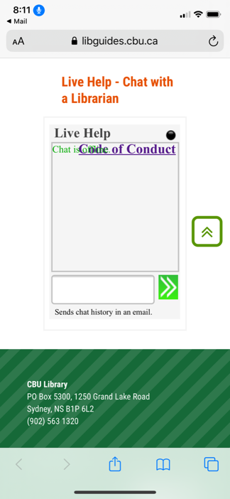 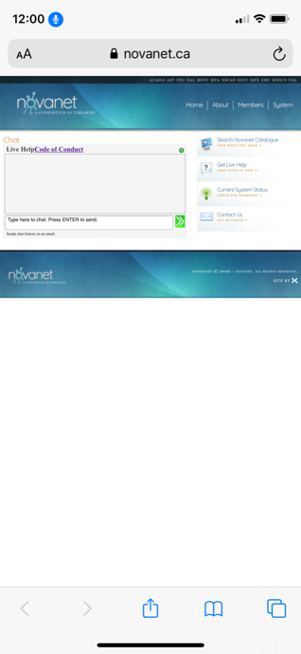

A similar issue happens when the browser screen is magnified by 400%. Again, this must be remediated. At 400% the icons become blurry and hard to understand, and these also need to be remediated.

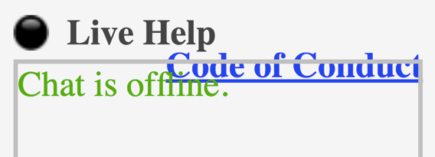



The interface itself is problematic, because it uses **extremely** small icons for functions, such as emailing chat history, opening a new window, sound, etc.

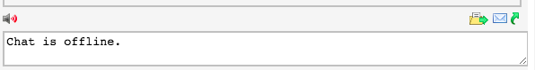

These must be changed to larger controls in an updated interface, because they may be extremely difficult to use by people with mobility and/or cognitive, neurological, intellectual and/or learning disabilities. Modernizing the interface with large icons is required.

In this icon area, there are blank links with nothing inside of them. One example is:

<a role="button" href="#" id="file" title="Sends a file to the operator." style="display: inline;"><span class="sprite"></a>

While some consultants may vary, I highly recommend that this code be changed. First, the title attribute should not be used. Very few users will access it. Second, the button code should be redone. Using plain text and styling the button using CSS is highly recommended. If icons must be used (for the sound for example), then CSS positioning can be used with example code below:

 <img src="image.jpg" alt="">  
  <button class="btn">Action Button Name</button>

As well, in this code for the sounds a title attribute was used. Title attributes are not recommended as few users will access them. Instead an aria-label should be added.

<a id="sounds" aria-pressed="true" role="button" href="#" title="Plays alert noise when operator sends new message." style="display: inline;"><span class="sprite" style="background-position: -10px 0px; width: 18px;"></a>

CSS styling was noted in the HTML code, as shown in the example above. This should all be removed and placed in a separate CSS style sheet. Currently, it may cause issues for people who need to change the colours and/or contrast in their browser by using their own stylesheet, app or browser settings.

On the widget page itself (<https://ca.libraryh3lp.com/chat/novanet@chat.ca.libraryh3lp.com?skin=10162&theme=gota&title=Live%20Help&identity=Librarian&css=%20//www.dal.ca/etc/designs/dalhousie/css/library/chatWidget.css&popout=1&sounds=1>) a page title is required <title> and needs to be added.

The sound is defaulted to the ‘on’ position, and this should be changed to the ‘off’ position.

Serif font was used in this widget, and it should be changed to sans serif for all textual areas. As well, the green and red on grey do not pass the WCAG 2.1 AA colour ratio, and need to be changed to pass Level AA. See the Colour Section for more details.

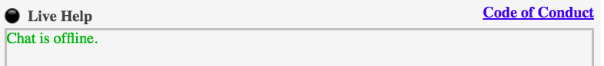

The colour combinations used in the chat, red and green and red and black, should be avoided, because they can cause issues for people who are colour blind, or for those who can’t see colour. The grey background makes all the text, including the black type, harder to read. Instead of using colour, names should be in black text, highlighted in bold, on a white background.

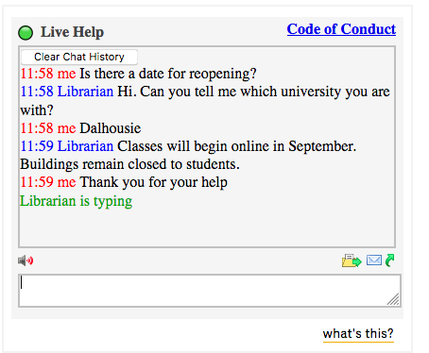

In the chat area colour is used as information, in the green circle next to the Live Help at the top. There is no other way of knowing that the chat is live, so text needs to be added to indicate a live chat is available.

One last note on this interface. It is very cluttered once it is in use. There is a large blue Code of Conduct that draws the eye, many colours in the interface itself, many icons and a what’s this link at the bottom. This may cause difficulties for some people with cognitive, neurological, intellectual and/or learning disabilities.



The testers reported that they enjoyed the quick interaction with librarians, and found the feature very handy. As one tester noted:

“Overall, I found the Live Help service, easy to use and very convenient. It avoids having to call someone and be put on hold before having a question answered.”

Another noted:

“The librarian responded promptly and with plenty of information and resources and links needed to help you. I found this way very fast and effective for communicating with the Librarian.”

As well, one tester noted that the chat history feature was very useful:

[The chat history]…was great and I had no idea about this function. My undergraduate university didn’t have this function as far as I know. I would definitely use Live Help more if I knew about this earlier! This function should be promoted.

There were some issues that the testers noted. Most should be addressed, and the final one should at least be considered.

The tester with ADD noted that they could not open the chat in a new window, because it was unclear how to accomplish this task. The tester with hearing, mobility and perception disabilities also could not open the chat in a new window when testing the CBU Live Help widget.

“I could not open the chat in a new window. I could not figure out how to do that and there wasn’t an option to do so as far as I can tell.”

The tester with ADD tested the Dal and CBU Live Help area, and noted the following. They felt that the process of using the Live Help was ‘smooth’ and ‘straight forward’. They noted some issues to consider. First, they would like the ability to copy and paste into the chat box. This would be a useful addition for all users.

“The only issue which I experienced is that you cannot copy and paste text into the chat box. This would be an issue if you formulated questions while the chat was offline and wanted to ask them quickly in the morning. Not a large issue though.”

They also noted another issue that the consultant recommends be remediated, as it may be an accessibility or usability issue for other users:

“Yes, you can clear the chat history by clicking the clear chat history button which is clear in the top left corner of the chat history box. This option appears after your first chat message is sent to the librarian. You know that the chat history is cleared as it shows up as a blank text box again. The only feature which I believe would be nice to add is that it could say text cleared in the chat history when you do clear it. Therefore, if done by accident you can see what has happened.”

The same tester noted a comment about opening the chat in a new window:

“This was a simple process once knowing what button to click, however maybe there should be word indicators as well to what this function does. I personally would not have known that button was to open in a new tab. This page is very slow to open and load on my computer. Once open, the function works great. It was simple and easy to get out of the window once the chat was complete, and it returns you to the original CBU site.”

One last issue noted by this tester was that when the chat was turned off on the CBU site, that you can still type in a message, and it responds with ‘message not received’. It is highly recommended that this be changed, so it works like some popular chat features, where the message then goes to an email to send to the person.

A similar issue was noted by the tester with hearing, mobility and perception disabilities. They found that on the offline CBU Live Help:

“When offline, the words the chat is offline does show, however, you can still type in the box so if one was not reading the words, the question can still be typed.”

This was echoed by the tester, who was older and had ADHD. They tested the Dal Live Help, and noted:

“First time I accessed the site, the help live chat was closed. I clicked the live help hours. Once on this page it would not close when I selected “close” in lower left corner. I had to exit page and site and use hyper link to reopen the site. I can’t find a way to ask a question when it is off line.”

The tester with autism noted the following about the sound option, and this should be reconsidered.

“When the noise is on but I am in another tab or another program in my computer, the noise would not go off **unless** I was in the Live Chat tab…I could turn the sound off. Nevertheless, it is my understanding that if someone puts the chat in a pop-up window, they must turn the sound off in both the website and the pop-up.”

They also noted that they did not receive the transcript by email, as requested. This mechanism should be investigated to know whether this was a one off issue. Lastly, when they tested the Novanet Live Help feature, they noted:

“When the website is off, I went to the link to see the office hours, but the “close” button was not working. This was the only issue I noticed when the live chat is off.”

The tester with hearing, mobility and perception disabilities tested the Dal Live Help and noted an issue:

“The only issue I had is that the live help is in a corner and half the size of the CBU Live Help section which just makes it harder to read as you would have to make it bigger to have a similar size and easier to read.”

The tester with mobility and cognitive disabilities, who uses text to speech software also noted issues with the chat (Dal Live Help but can apply to all Live Help widgets) and how it responded to the software. These issues should be remediated.

“Tested my text to speech software. I highlighted the chat responses with my cursor, and pressed “play” and it won’t read the chat box responses (it reads the top of the page instead)…. That’s not great. Additionally, I can only highlight each line, not the whole chat (so that’s tedious). This needs to be changed: allowing text to speech software to read the responses within the chatbox. I can imagine this would greatly benefit many students.”

The tester with low vision, who uses magnification, had some difficulty with the Dal and Novanet Live Help features (and this can apply to the others). They noted the following issues when they were using these widgets. Note that more testing would be required to gauge whether the sound and files issues were problematic for others with low vision.

“I could access the live chat and the interface worked well. At first I didn’t know whether the chat was available or not so I typed a message. The librarian replied so that’s how I figured out that it was on. I appreciated the interface and was able to zoom in enough to make it visible. I appreciated the colour coding of blue/red for the librarian and me, and found no issues communicating this way.

“I could not access any sound controls, nor did I have the option of sending any files.”

“I could not open the chat in a new window. I am unsure of how to do that. If this is desired then functionality should be added that is clear and prominently displayed. For example a button “Open chat in new window” would be very helpful.”

The tester with low vision, who uses magnification, noted more difficulties with the Dal Live Help interface:

**“**The few differences revolved around how the live help segment is embedded into the page. It is not a very large screen area and required me to use the iPad screen magnification setting. I could still access the tool and the queries and replies were the same, however it was inconvenient to have to use the magnifier. I would have preferred a link to novanet live help, or for the live help to open in a new screen so that I could see the help full screen. Similarly to Novanet, I could not manipulate the sound or send files…”

The tester with the hearing and visual disability, who used a screen reader noted major issues with the Live Help at the Novanet site. This widget must be recoded and retested.

“Voice over- the librarian was really quick to respond however, I didn’t hear all of the responses. It beeped thrice but the response was not read. Jaws: first, I noticed that my history was not cleared even though I cleared it on my Mac. Jaws read all my and the librarian’s messages each time the librarian responded. I didn’t read only the immediate response but all the messages…”

This tester was able to use the send a file feature, but it was confusing:

“Voice over- Yes, I can but I had to tab to the beginning and the end of the page before I found the choose file button. Jaws- Yes, I could. Had to tab back and forth though.”

This tester was able to clear the chat history, but didn’t get indication that it was cleared. ARIA code must be added to tell screen reader users that the chat has cleared.

“Yes, I could clear it, but I didn’t know when it cleared. It didn’t say anything. Jaws: yes, I could clear it, but I found out that the messages sent on my mac did not clear so I’m not sure it actually cleared this time.”

The tester tried the Live Help when it was not online, and the process was confusing and needs to be remediated.

“Voice over- it didn’t say that it was unavailable. I saw the Live hours button, but voiceover said, “not secure” and didn’t give me any information about the hours. Jaws- it wasn’t clear that it was off. There was an option to check the live hours and I assume a student who wants live help will press that button and when I pressed it, Jaws said, “not secure” and there was no information on the page about the hours. This means there is no information for me at all.”

The tester with the hearing and visual disability, who used a screen reader noted issues with the CBU Live Help widget as well. They noted particular barriers when they didn’t focus only on the chat area. They relate their experience:

“Voiceover- it was fine. I didn’t hear all the responses after I started tabbing around the page. It should say “Don’t leave chat area” or something like that to warn you. Jaws: it was ok, but I didn’t get any response once I started tabbing around. I only got the beeper ring. For both Jaws and voice over-The chat really needs to be worked on to ensure I can listen to the responses in and out of the chat area.”

Here too, they did not know that the chat history was cleared.

“Voice over- I could but I don’t know if it actually did. Jaws yes, I could but it didn’t say it was cleared. I just heard the Jaws sound.”

Finally, a tester noted one suggestion that should be considered.

“…[an]…improvement I would suggest is more suitable office hours. As a student, I am typically in classes during the day and therefore would only be available to avail of the Live Help service in times outside office hours.”

**MSVU Live Help (Mathematics Page) **PRIORITY\*\***

The tester with low vision, who uses magnification, found it hard to use the Live Help feature on the MSVU Mathematics page. These issues should be considered, and remediated.

“I struggled to find the live help. I had to select the tab “Articles and Journals” in order to see the box below the header options. I believe this is because of my mobile browser use and the zoomed settings on my iPad. I couldn’t tell for a moment if the live help was on and available. I had to type into the search box.   
  
I eventually realised that the green dot on the top right of the window indicated the live help was on. Perhaps this could be made clearer by adding the text “Live help ON” or off as well as the green/red indicator. I found it useful that the chat was colour coded (blue for the librarians messages and red for mine). This helped distinguish who said what and made it easier to read. After trying the live help during the day I found it was easy to discern whether it was off using the indicator light on the top right. I was able to send the chat transcript to an email with relative ease and had no issues with receiving the email.   
  
Under the chat box there is text with the library’s email and phone number. This text was incredibly small and the light blue of the email didn’t contrast well with the white background. It would be helpful to have that information in larger print/higher contrast colours so that I don’t have to zoom excessively to see it.”

The tester with the hearing and visual disability, who used a screen reader noted an issue with the MSVU Mathematics Live Help Section. It is recommended that the Live Help be recoded and retested, as improvements can be made to the interface (see other issues in this section). See the Image Section for information on alternative text for the offline images to help solve the other part of this issue.

“Voiceover- First, it did not tell me it was the Live Help section. It just said “Toolbar”. I wouldn’t have known it was Live Help if I didn’t read the instruction of the test telling me to chat here. However, I was able to use it well. The librarian was really quick to respond. Quicker than I thought. There is one issue with tabbing to the chat area. It was unclear where the chat area was when I tried to tab out and tab in again. It took patience to listen slowly and carefully. I suggest there should be a concise “Chat area” option there.”

“Jaws- yes, I could find the Live Chat fine. Even though its called Research Help on the page. After I sent the message to the operator, it took me back to the beginning of the page and when I tabbed to the Chat area, I couldn’t find it, so I had to tab around the page thrice to find it. When I did, I could not read the response of the operator. I could only type a message once again. I emailed the chat to a dummy email fine. I also cleared it fine…. I think? There was no way to know. After I cleared the history and left the page, another message came in, but I’ve already left.”

Another issue noted with the JAWS screen reader was that while the VoiceOver screen reader found the Live Help was online, the JAWS one did not tell the user it was unavailable. Again, a new script should be developed, and retested.

#### CSS

##### Internal CSS

CSS needs to be located in external CSS files, not in the HTML files, so it can be updated in a consistent manner. CSS is present in the HTML code, and this should be removed, if possible, and put into a separate css file.

**Acadia Biology *SECONDARY PRIORITY\***Extensive CSS code was in the HTML code, and should be removed and put into a separate CSS file.

**Acadia Business *SECONDARY PRIORITY\***

Extensive CSS code was in the HTML code, and should be removed and put into a separate CSS file.

**Acadia Kinesiology *SECONDARY PRIORITY\***

Extensive CSS code was in the HTML code, and should be removed and put into a separate CSS file.

**NSCC *SECONDARY PRIORITY\***

Extensive CSS code was in the HTML code, and should be removed and put into a separate CSS file.

**MSVU **PRIORITY\*\***

Extensive CSS code was in the HTML code, and should be removed and put into a separate CSS file. For this web page, the NU HTML validator pointed out code errors, relating to this CSS issue, which must be remediated

**Dal Aboriginal Law **PRIORITY\*\***

Extensive CSS code was in the HTML code, and should be removed and put into a separate CSS file. For this web page, the NU HTML validator pointed out major code errors, relating to this CSS issue, which must be remediated.

#### HTML Code Errors

##### Importance and Users Impacted

There should be no HTML code errors present on web pages, if possible. This makes the site better for people, as well as search engines. The NU html checker (<https://validator.w3.org/nu/>) should be used to find, and then fix, errors.

##### Findings

**Acadia Biology *SECONDARY PRIORITY\***There were code errors noted on this web page. The code should validate, or be as close as possible. All errors should be checked and remediated. Note that some errors are noted in this report, so remediation should be done and then all pages should be rechecked for final errors to fix.

**Acadia Business *SECONDARY PRIORITY\***

There were code errors noted on this web page. The code should validate, or be as close as possible. All errors should be checked and remediated. Note that some errors are noted in this report, so remediation should be done and then all pages should be rechecked for final errors to fix. Note that on this page there were multiple instances of duplicate IDs used. This should be remediated, as this can cause issues for some users with disabilities.

**Acadia Kinesiology *SECONDARY PRIORITY\***

There were code errors noted on this web page. The code should validate, or be as close as possible. All errors should be checked and remediated. Note that some errors are noted in this report, so remediation should be done and then all pages should be rechecked for final errors to fix.

**NSCC *SECONDARY PRIORITY\***

There were code errors noted on this web page. The code should validate, or be as close as possible. All errors should be checked and remediated. Note that some errors are noted in this report, so remediation should be done and then all pages should be rechecked for final errors to fix.

**MSVU **PRIORITY\*\***

There were code errors noted on this web page. The code should validate, or be as close as possible. All errors should be checked and remediated. Note that some errors are noted in this report, so remediation should be done and then all pages should be rechecked for final errors to fix.

**Dal Aboriginal Law **PRIORITY\*\***

There were code errors noted on this web page. The code should validate, or be as close as possible. All errors should be checked and remediated. Note that some errors are noted in this report, so remediation should be done and then all pages should be rechecked for final errors to fix.

## **Disclaimer**

* The Client acknowledges that the requirements of the Accessibility for Manitobans Act (AMA), Accessibility Act of Nova Scotia (AA), Accessibility for Ontarians with Disabilities Act (AODA), Revised Section 508 (Refresh), and/or any other American and/or Canadian provincial and/or federal laws, rules, codes, ordinances and regulations as they apply to the services provided, will be subject to various and possibly contradictory interpretations.
* The evaluation of systems, practices, workflows, policies, materials, including, but not restricted to, web sites, social media postings, documents, maps, signage, apps and similar or unique electronic, digital or print entities, etc. and/or content, to ascertain whether they conform to general accessibility best practices and/or recommendations, and/or Revised Section 508 (Refresh), and/or WCAG 2.0 and/or WCAG 2.1 and/or WCAG 2.2 is done by The Consultant.
* Some criterion under Revised Section 508 (Refresh) and/or WCAG 2.0 and/or WCAG 2.1 and/or WCAG 2.2 can be checked with automated online checkers. However, most criterion rely exclusively, or partially, on manual checking by The Consultant. A Pass/Fail under Revised Section 508 (Refresh), and/or WCAG 2.0 and/or WCAG 2.1 and/or WCAG 2.2 criterion and/or more general accessibility recommendations are decided upon by The Consultant using its reasonable professional efforts and judgment to interpret applicable accessibility requirements for Revised Section 508 (Refresh) and/or WCAG 2.0 and/or WCAG 2.1 and/or WCAG 2.2 and/or general accessibility best practices and/or recommendations.
* Other Consultants may vary in their opinions on the decision of a Revised Section 508 (Refresh) and/or WCAG 2.0 and/or WCAG 2.1 and/or WCAG 2.2 criterion Pass/Fail and the rationale behind it/them, when they complete manual assessments of the guidelines of said Client systems, practices, workflows, policies, materials and/or content, as noted above.
* Other Consultants may vary in their opinions on general accessibility best practices and/or recommendations and the rationale behind it/them, when they complete manual assessments of said Client systems, practices, workflows, policies, materials and/or content, as noted above.
* While The Consultant makes every effort to audit all said Client systems, practices, workflows, policies, materials and/or content, as noted above, during the contract period, there may be items that were inadvertently left out of reports, audits, and similar.
* The Consultant may provide seminars, talks, courses, panel discussions, training sessions, webinars, workshops and/or similar entities based on, and not exclusive to, general and/or specific accessibility best practices and/or recommendations, The Consultant’s experiences and/or WCAG 2.0 and/or WCAG 2.1 and/or WCAG 2.2 and/or Revised Section 508 (Refresh). These are decided upon by The Consultant using its reasonable professional efforts and judgment to interpret applicable accessibility requirements for Revised Section 508 (Refresh) and/or WCAG 2.0 and/or WCAG 2.1 and/or WCAG 2.2 and/or general and/or specific accessibility best practices and/or recommendations and/or The Consultant’s experience. Other Consultants may vary in their opinions and the rationale behind it/them, when they provide similar services.
* The Consultant will use its reasonable professional efforts and judgment to interpret applicable accessibility requirements in effect as of the date of the work and as they apply to the accessibility consulting services. The Consultant, however, cannot and does not warrant or guarantee that the work done for The Client will comply with all possible interpretations of the accessibility requirements and/or the requirements of the Accessibility for Manitobans Act (AMA), Accessibility Act of Nova Scotia (AA), Accessibility for Ontarians with Disabilities Act (AODA), Revised Section 508 (Refresh) and/or any other American and/or Canadian provincial and/or federal laws, rules, codes, ordinances and regulations as they apply to the services provided, and The Consultant shall, accordingly, not have any liability to The Client in connection with same.

## Copyright

© Copyright 2020 Access Changes Everything. This report, and the recommendations contained in it, are only to be used by The Client for the purpose contracted. No other use of this report is authorized. This report is not to be distributed, or used by any other business, organization, individual, vendor, 3rd party or organization, member of the public, without the express written permission from Access Changes Everything.